_____________________

**____________________**

**______**

**PHP PROJECT**

Submitted by:

|  |
| --- |
| **PRADIPTA PAUL** |

*Under the guidance of Mr. Amalendu Das on behalf of*

**Webel Informatics Ltd**

**ACKNOWLEDGEMENT**

I am extremely grateful and remain indebted to my guide Mr. Amalendu Das of Webel Informatics Limited for being a source of inspiration and for his constant support in the implementation and evolution of the project.

I am thankful to him for invaluable suggestions which benefitted us a lot while developing this project on “ONLINE HOTELS & RESORTS BOOKING SYSTEM”.

DATE: 23/08/2020

PRADIPTA PAUL

M.SC (COMPUTER SCIENCE),

BANARAS HINDU UNIVERSITY

COMPLETE

**CONTENTS**

|  |  |  |
| --- | --- | --- |
| **SERIAL NO** | **TOPICS** | **PAGE NO** |
| 1 | Abstract | 4 |
| 2 | Introduction | 5 |
| 3 | Problems of current system | 6 |
| 4 | Web Application Survey | 7-8 |
| 5 | SDLC of the project | 9-13 |
| 6 | Database Design | 14-17 |
| 7 | Use Case Diagram | 18 |
| 8 | Entity Relationship Diagram | 19 |
| 9 | Data Flow Diagram | 20 |
| 10 | Development | 21-35 |
| 11 | Testing | 36-42 |
| 12 | Physical Design | 43-80 |
| 13 | Conclusion | 82 |
| 14 | Limitations | 83 |
| 15 | Future Scope of Project | 84 |
| 16 | Bibliography | 85 |

**ABSTRACT**

Hotel and resort booking system is an essential part of the Hospitality industry, because it assures the proper work of the hotel, making it useful and allows booking a hotel room or a resort online. It keeps data for the workers and management about the rooms, the overall hotel, or a resort. This system reduces most of the paperwork and making it an essential asset to have for every hotel and resort. Analyzes and improves the current reservation system. This work proposes to implement an in-depth analysis of the system. Search the theory of hotels, bookings, online bookings, and online booking systems.

Try to update the current position in the hotel and resort booking business. Also, create a small model, explaining how the system will work from the user side.

**INTRODUCTION**

**Dipta**is a hotel and resort booking website which gives the facilities for reserving hotels and resorts for customers online. They conduct their business in all the cities of India. At an earlier time, if a customer wants to book a hotel room or resort, they had to visit in the office of that hotel and resort for checking the availability or negotiation. But at today's time, they have determined to change their booking system from manual to a web-based system or online system. It will benefit to engage more customers and helps them to book hotel rooms, and resorts easily with no effort. It will benefit the hotel and resort company to maintain the customers booking with no effort and also to keep customer data protected. It will also update to store records of their customer's online booking requests as well as easy to give feedback to the customers. For producing an online booking facility, many hotel and resort company's hired a developer to build the web system for there company. In this documentation, it explains how the web-based online system will be created and performed and the design. Now a day's the web-based application is also available on our Smartphone's it is easily reachable and always available.

**PROBLEMS OF MANUAL SYSTEM**

The hotels and resorts which have a manual booking system, experiencing some difficulties issuing booking applications of consumers. All the essential booking stuffs are being done in hard copy. So it becomes much challenging for officers to keep the records updated all the time. For example, if the customers need to modify the check-in date it becomes challenging for them to find out the customers booking details for renewing as there are so many customers booking records. Again, concerning the current system customers cannot give feedback online, and also officers cannot reply to them immediately. Besides travelers from other countries need to call immediately for booking purposes. So they cannot get the opportunity to view their apartment rooms or hotel rooms before they make a book.

Secondly, in hotels, one needs to use the reception desk to check-in and get your hotel number. That can have good and bad parts. For example, a bus with tourists arrives at a hotel at night and only one receptionist is working. He has to do everything manually and it can take an extremely long time. Guests are tired, but they have to fill out some forms or just wait in line for over an hour to get their rooms sorted, while with a QR code it’s possible to receive your room card in a bit over a minute.

For a guest to check-in, he has to wait for the receptionist to be available, then the worker asks for reservation information. Often that information can be printed out on paper or just documents are used to prove a reservation. The receptionist has to provide guest forms to be filled and/or just make the client wait, sometimes longer than it should be, because he has to find the reservation. Check room availability, if it’s clean and ready to be used, confirm, and check every little detail possible. It can take a very long time and if there are a lot of guests waiting for service it can get extremely frustrating for the guest. Another problem, are days when you don’t want to deal with people. For example, you are very tired and just want to get to your room and relax after a long flight/trip/train ride. Guests and receptionists can be both in a bad mood and then problems can occur.

**WEB APPLICATION SURVEY**

We have visited some selective web sites for our design and implementation purposes. These websites are given below.

**https://www.trivago.in/**

I followed this site to get some idea how to create the website.

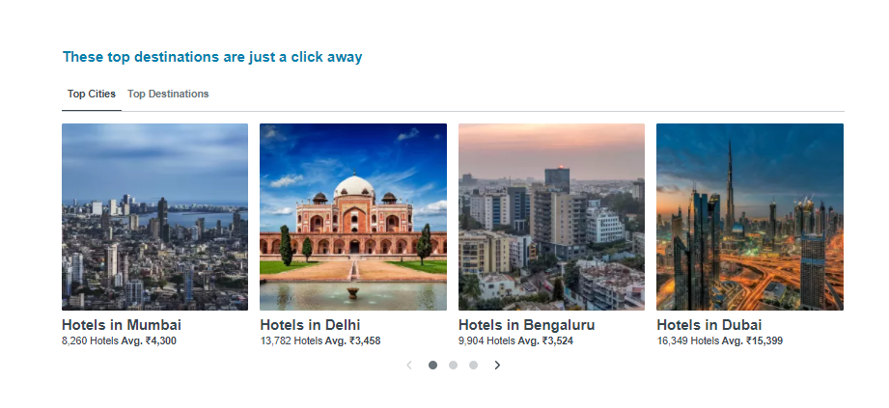

**https://www.oyorooms.com/**

I followed this site to get some idea how to create the website.

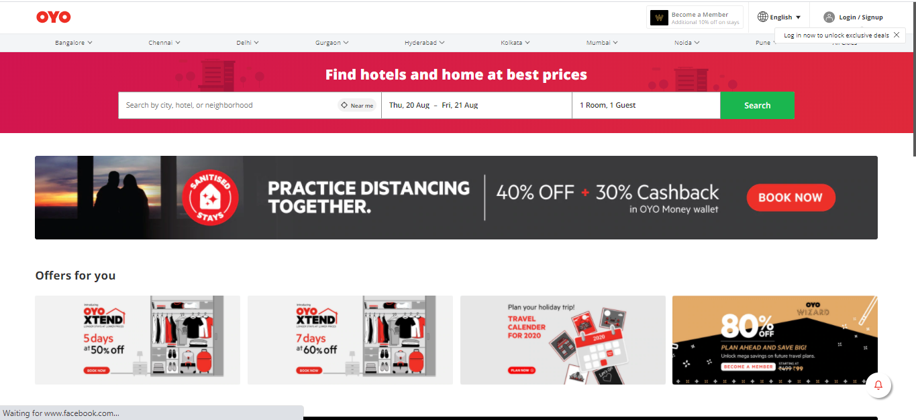

**SDLC OF THE PROJECT**

This project is a Web Application and going to be developed using PHP. Similar to all other software projects, this project too has its own Software Development Life Cycle (SDLC). The SDLC of this project will be discussed under the following heads.

1. **FEASIBILITY STUDY:**

The purpose of the feasibility study is not to solve the problem, but to determine the problem is worth solving. This helps to decide whether to proceed with the problem or not. It involves the analysis of the problem & collection of all relevant information relating to the product such as items that would be input to the system, processing required to carried those data, the output data required to be produced by the system as well the various constraints on the behavior of the system. "Web based placement management system” had undergone the feasibility study so that the proposed system is possible for development and deployment. The feasibility study concentrates on the following, such as Operational Feasibility, Technical Feasibility, and Economic Feasibility

**1.1 ECONOMIC FEASIBILITY:** The economic feasibility study evaluates the cost software development against the ultimate income or benefits get from the developed system. There must be scope for profit after the success completion of the project.

**1.2. TECHNICAL FEASIBILITY:** Technical feasibility study compares the level of technology available in the software development firm and the level of technology required for the development of the product. The level of technology consists of the programming language, the hardware resources, other software tools etc.

**1.3.**  **OPERATIONAL FEASIBILITY:** Operational feasibility study tests the operational scope of the software to be developed. The proposed software must have high operational feasibility. The usability will be high.

**2. TOOLS AND PLATFORM USED FOR DEVELOPMENT :**

|  |  |
| --- | --- |
| TECHNOLOGIES : | PHP ( Hypertext Preprocessor ) |
| **WEB DEVELOPMENT TOOLS :** | HTML, CSS, JAVASCRIPT,BOOTSTRAP |
| **WEB SERVER :** | APACHE 9.0 |
| **RDBMS / BACK-END :** | MySQL |
| **OPERATING SYSTEM :** | WINDOWS 10 |
| **OTHER APPLICATION SOFTWARES USED :** | MS Word 2007 (For Documentation) |
| **HARDWARE CONFIGURATION OF THE MACHINE USED FOR DEVELOPMENT :** | Intel(R) Core(TM)i3 CPU @2.80GHz ,  4GB RAM,  500GB HDD. |

**3. REQUIREMENT ANALYSIS :**

**3.1. SOFTWARE REQUIREMENTS:**

* **OS**: Windows
* **Database**: MySql
* **Server**: Apache Server (Free-Open source)
* **Language**: PHP environment (Free-Open source)
* **Front end**: Browser with support for JavaScript

**3.2. HARDWARE REQUIREMENTS :**

* Processor – i3
* Hard Disk – 50 GB
* Memory – 2GB RAM
* Mouse – Any Standard
* Keyboard – Any Standard
* Monitor – Any color monitor
* Local Area Network Preferable

**3.3. FUNCTIONAL REQUIREMENTS :**

* The system supports customers booking.
* Customers can search based on hotels, resorts and places (ex. Delhi, Kolkata)
* When a customer search for hotels and resorts, the search result must contain hotel or resort information (Address and Price) and also its availability within choosing check in and check out date.
* Customers can book online and pay with credit or debit card.
* The system must send booking confirmation email after successful payment.
* Customers able to check their booking status from their individual account.
* Customers can send feedback or call the company for booking purposes.

**3.4. NON-FUNCTIONAL REQUIREMENTS :**

* The system must ensure that all the transferable data as for examples customers credit or debit card number, CVV Code, e-payment should be done in secured connection.
* The system must be able to handle multiple transactions a time.
* The system must provide customers 24*7 hours online booking service.
* The system should support almost all the browsers (Internet Explorer, Safari, Chrome, and Firefox).
* System should send the newsletter about ongoing promotions or deal to registered customers.

**3.4. EXTERNAL INTERFACE REQUIREMENTS :**

**Admin Interface**

Some of the user interface screens are described in the following table :

|  |  |  |
| --- | --- | --- |
|  | **Screen Name** | **Description** |
|  |  |  |
|  | Login | Only admin can log in to the site. |
|  |  |  |
|  |  | Table 4:External Interface Requirements |
| **Error Messages** | |  |

Yet the system has been tested properly on the local host machines and also the system generated errors have been checked by using exception handling mechanism but there can be also some error occur at the runtime unexpectedly due to server failure.

Here we have also provided some user defined error messages which act as a warning message to user. This user defined error messages do not follow any number to identify them. We have used a particular warning message for particular case when a user does not properly interact with them. For example, if user properly log-in then **'Login successful'** alert message is shown**,** otherwise, **'Incorrect email-id or password!!!'** is visible.

**4. REQUIREMENT DOCUMENTATION:**

This step involves documenting the requirements in various forms, including summary lists, natural language documents, visual documents, use cases, user stories, or process specifications. A requirement specification document is categorized in different ways according to the stakeholders’ need, helping to create a clear contract between development and business. The following sections include the different segments –

This document is for the developers, testers and customers to make the understanding of the project is easier. The following explanation of the abbreviations will help in the following purpose.

|  |  |
| --- | --- |
| **ABBREVIATIONS** | **FULL FORM** |
| PHP | Hypertext Preprocessor |
| HTML | Hyper Text Markup Language |
| CSS | Cascading Style Sheet |
| ADMIN | Administrator, who controls the operations of the system |

**5. DESIGN / SOLUTION/METHODOLOGY :**

**5.1. DATABASE DESIGN :**

**TABLE STRUCTURES / DATA DICTIONARY :**

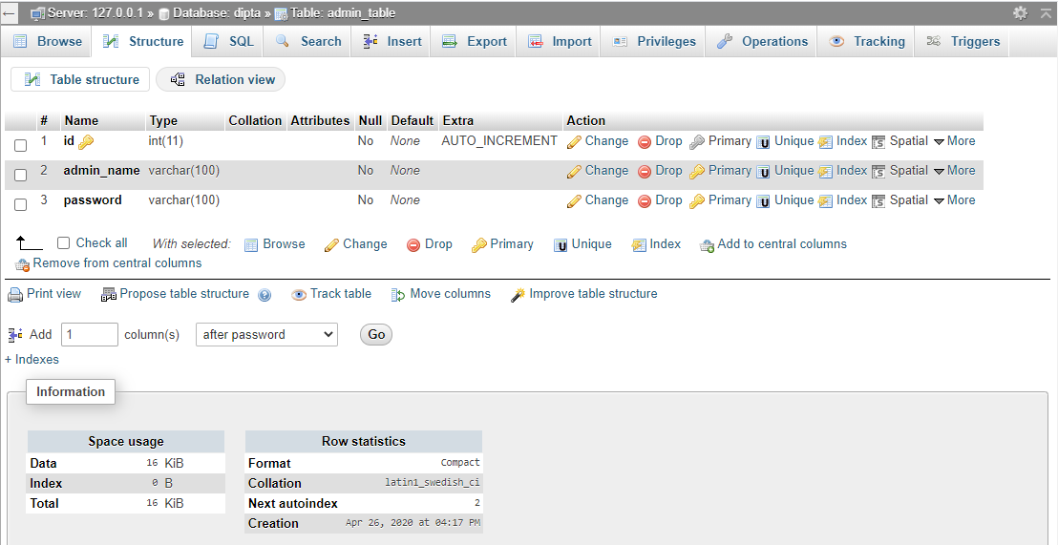

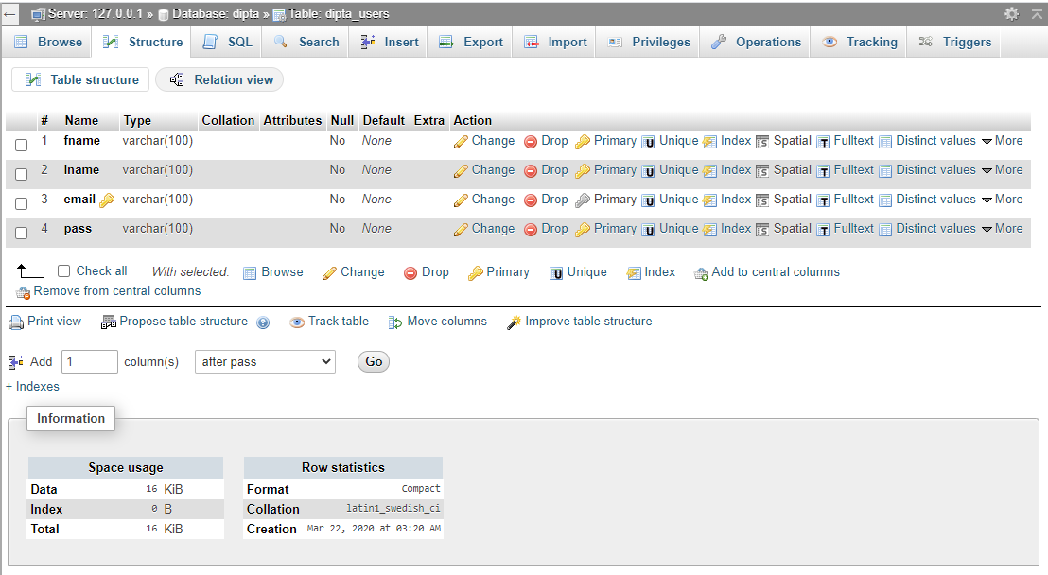

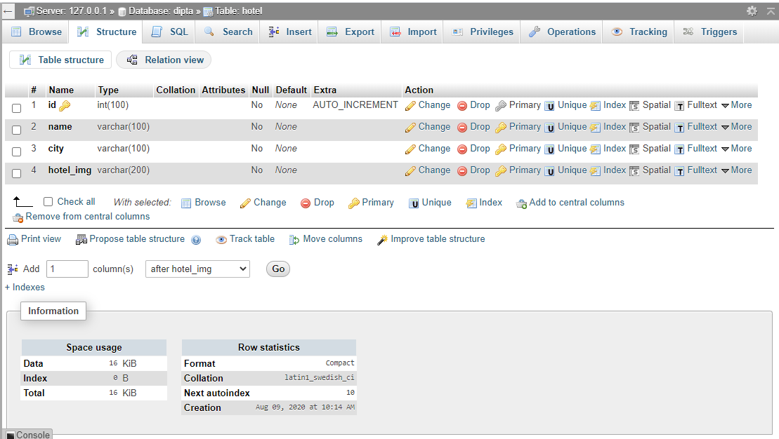

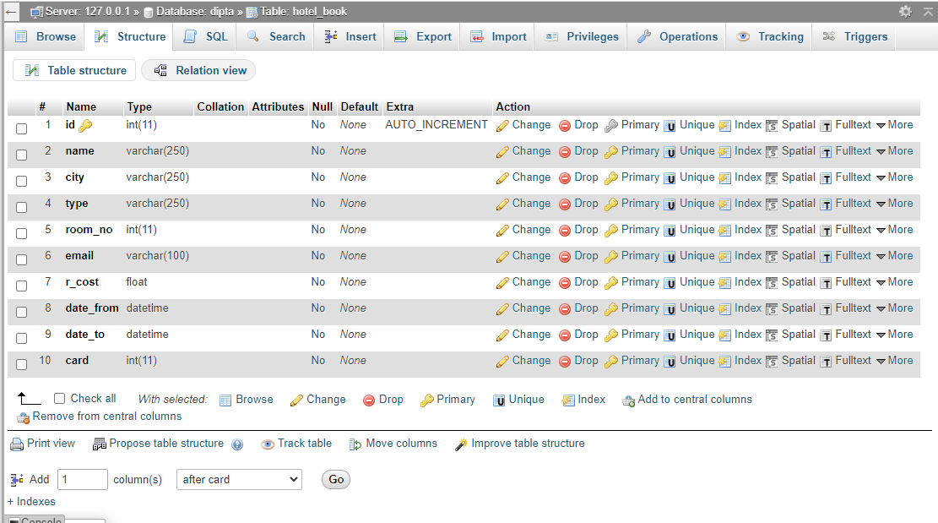

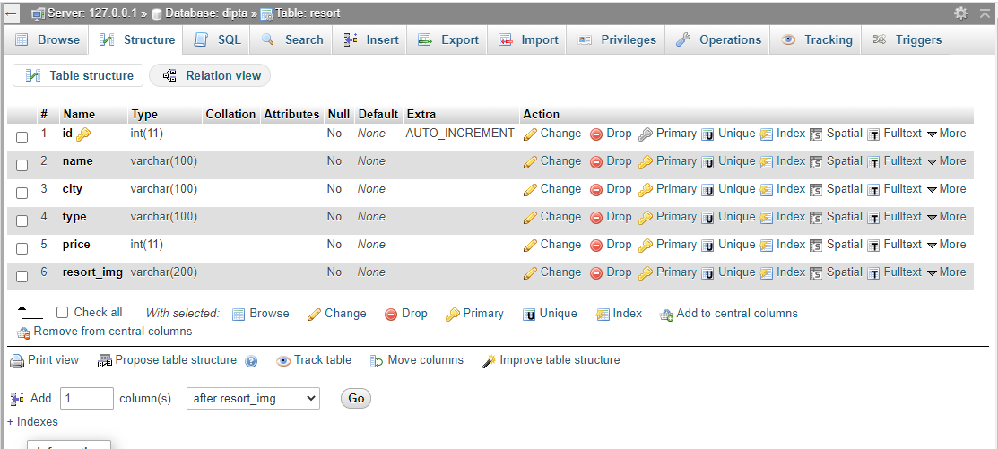

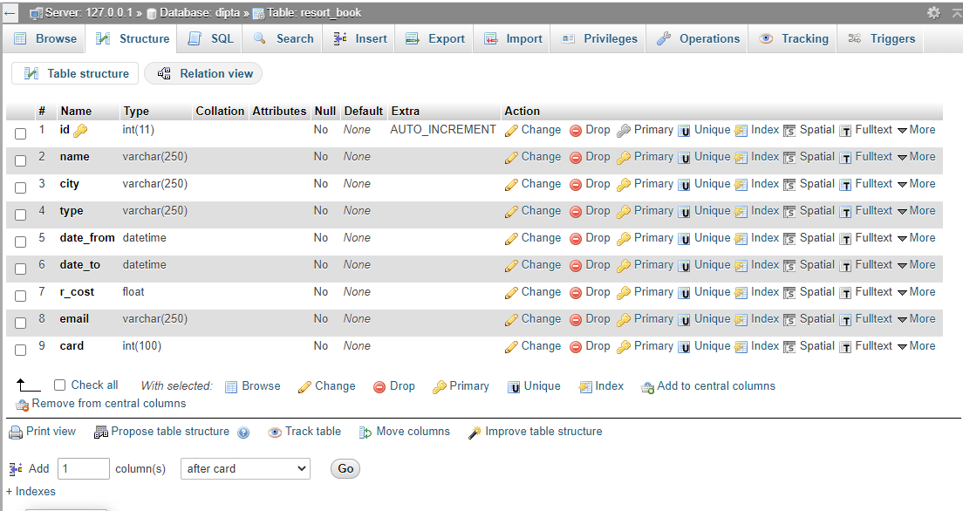

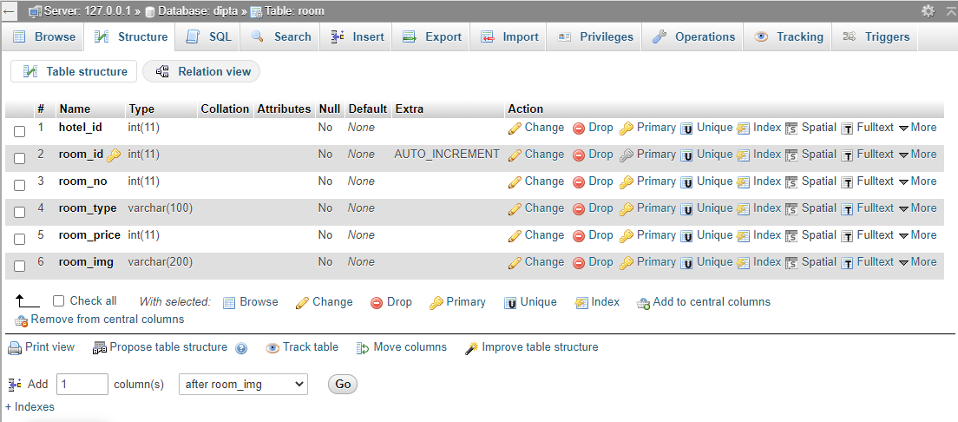

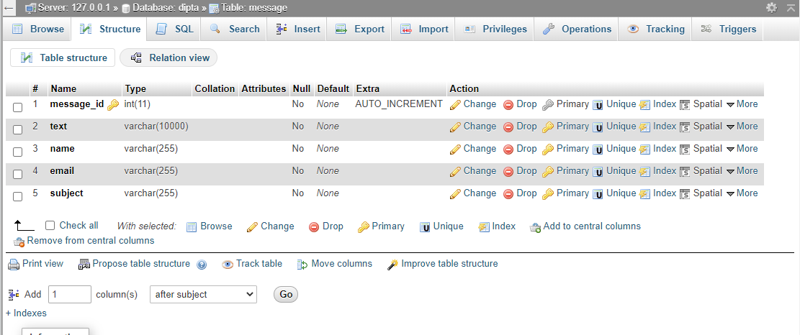

**5. 2. ARCHITECTURAL DESIGN :**

**(USE CASE DIAGRAM) :**

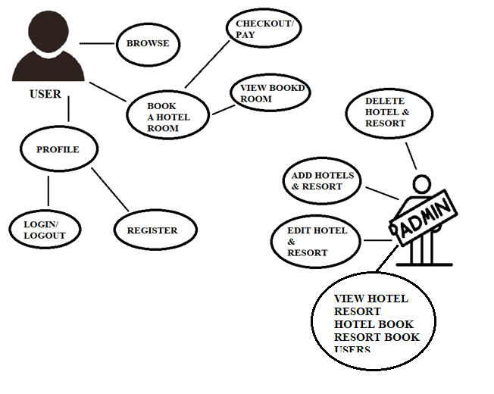

1. **ENTITY RELATIONSHIP DIAGRAM (ERD) :**

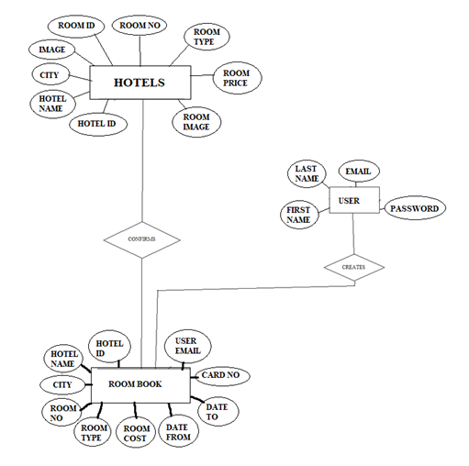

1. **DATA FLOW DIAGRAM (DFD) :**

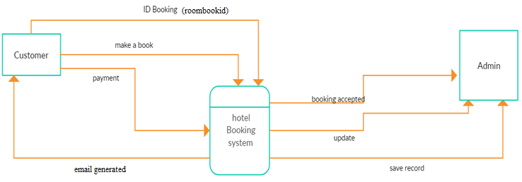

**LEVEL 0: DFD**

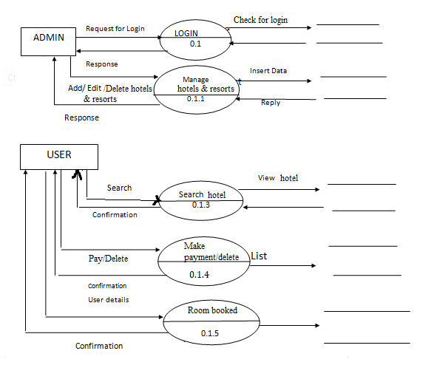

**LEVEL 1 : DFD**

**8. DEVELOPMENT:**

After designing the structures of all the modules and database, the project is developed using, MVC(Model View Controller) Architecture. Implementation of this architecture separates the three parts from each other- Data, View and Business Logic and hence they can be developed separately. The View designed using HTML and the logic is embedded in PHP. In this project, we will be using PHP to hold the data. This PHP will be having only attributes, variables representing corresponding data fields with no methods. The overall development is done and executed with the help of web server like Apache.

**HTML - OVERVIEW**

**HTML** or **Hypertext Markup Language** is the standard [markup language](http://en.wikipedia.org/wiki/Markup_language) used to create [web pages](http://en.wikipedia.org/wiki/Web_page).

HTML is written in the form of [HTML elements](http://en.wikipedia.org/wiki/HTML_element) consisting of *tags* enclosed in [angle brackets](http://en.wikipedia.org/wiki/Angle_brackets) (like <html>). HTML tags most commonly come in pairs like <h1> and </h1>, although some tags represent *empty elements* and so are unpaired, for example <img>. The first tag in a pair is the *start tag*, and the second tag is the *end tag* (they are also called *opening tags* and *closing tags*). Though not always necessary, it is best practice to append a slash to tags which are not paired with a closing tag.

The purpose of a [web browser](http://en.wikipedia.org/wiki/Web_browser) is to read HTML documents and compose them into visible or audible web pages. The browser does not display the HTML tags, but uses the tags to interpret the content of the page. HTML describes the structure of a website [semantically](http://en.wikipedia.org/wiki/Semantic) along with cues for presentation, making it a [markup language](http://en.wikipedia.org/wiki/Markup_language) rather than a [programming language](http://en.wikipedia.org/wiki/Programming_language).

HTML elements form the building blocks of all [websites](http://en.wikipedia.org/wiki/Website). HTML allows [images and objects](http://en.wikipedia.org/wiki/Img_(HTML_element)) to be embedded and can be used to create [interactive forms](http://en.wikipedia.org/wiki/Fieldset). It provides a means to create [structured documents](http://en.wikipedia.org/wiki/Structured_document) by denoting structural [semantics](http://en.wikipedia.org/wiki/Semantic) for text such as headings, paragraphs, lists, [links](http://en.wikipedia.org/wiki/Hyperlink), quotes and other items. It can embed [scripts](http://en.wikipedia.org/wiki/Scripting_language) written in languages such as [JavaScript](http://en.wikipedia.org/wiki/JavaScript) which affect the behavior of HTML web pages.

**CSS - OVERVIEW**

It is a [style sheet language](http://en.wikipedia.org/wiki/Style_sheet_language) used for describing the [look and formatting](http://en.wikipedia.org/wiki/Presentation_semantics) of a document written in a [markup language](http://en.wikipedia.org/wiki/Markup_language). While most often used to style [web pages](http://en.wikipedia.org/wiki/Web_page) and [interfaces](http://en.wikipedia.org/wiki/Interface_(computing)) written in [HTML](http://en.wikipedia.org/wiki/HTML) and [XHTML](http://en.wikipedia.org/wiki/XHTML), the language can be applied to any kind of [XML](http://en.wikipedia.org/wiki/XML) document, including [plain XML](http://en.wikipedia.org/wiki/Plain_Old_XML), [SVG](http://en.wikipedia.org/wiki/Scalable_Vector_Graphics) and [XUL](http://en.wikipedia.org/wiki/XUL). CSS is a cornerstone specification of [the web](http://en.wikipedia.org/wiki/The_web) and almost all web pages use CSS style sheets to describe their presentation.

CSS is designed primarily to enable the separation of document content from document presentation, including elements such as the [layout](http://en.wikipedia.org/wiki/Page_layout), [colors](http://en.wikipedia.org/wiki/Color), and [fonts](http://en.wikipedia.org/wiki/Typeface).[[1]](http://en.wikipedia.org/wiki/Cascading_Style_Sheets#cite_note-1) This separation can improve content [accessibility](http://en.wikipedia.org/wiki/Accessibility), provide more flexibility and control in the specification of presentation characteristics, enable multiple pages to share formatting, and reduce complexity and repetition in the structural content .

CSS can also allow the same markup page to be presented in different styles for different rendering methods, such as on-screen, in print, by voice (when read out by a speech-based browser or [screen reader](http://en.wikipedia.org/wiki/Screen_reader)) and on [Braille-based](http://en.wikipedia.org/wiki/Braille_display), tactile devices. It can also be used to allow the web page to display differently depending on the screen size or device on which it is being viewed. While the author of a document typically links that document to a CSS file, readers can use a different style sheet, perhaps one on their own computer, to override the one the author has specified. However if the author or the reader did not link the document to a specific style sheet the default style of the browser will be applied

**MySQL - OVERVIEW**

MySQL is developed, distributed, and supported by Oracle Corporation. MySQL is a database system used on the web it runs on a server. MySQL is ideal for both small and large applications. It is very fast, reliable, and easy to use. It supports standard SQL. MySQL can be compiled on a number of platforms.

The data in MySQL is stored in tables. A table is a collection of related data, and it consists of columns and rows. Databases are useful when storing information categorically.

**FEATURES OF MySQL:**

Internals and portability:

* Written in C and C++.
* Tested with a broad range of different compilers.
* Works on many different platforms.
* Tested with Purify (a commercial memory leakage detector) as well as with Val grind, a GPL tool.
* Uses multi-layered server design with independent modules.

#### Security:

* A privilege and password system that is very flexible and secure, and that enables host-based verification.
* Password security by encryption of all password traffic when you connect to a server.

#### Scalability and Limits:

* Support for large databases. We use MySQL Server with databases that contain 50 million records. We also know of users who use MySQL Server with 200,000 tables and about 5,000,000,000 rows.
* Support for up to 64 indexes per table (32 before MySQL 4.1.2). Each index may consist of 1 to 16 columns or parts of columns. The maximum index width is 767 bytes for InnoDB tables, or 1000 for MyISAM; before MySQL 4.1.2, the limit is 500 bytes. An index may use a prefix of a column for [CHAR](https://dev.mysql.com/doc/refman/5.0/en/char.html), [VARCHAR](https://dev.mysql.com/doc/refman/5.0/en/char.html), [BLOB](https://dev.mysql.com/doc/refman/5.0/en/blob.html), or [TEXT](https://dev.mysql.com/doc/refman/5.0/en/blob.html) column types.

#### CONNECTIVITY:

Clients can connect to MySQL Server using several protocols:

Clients can connect using TCP/IP sockets on any platform.

On Windows systems in the NT family (NT, 2000, XP, 2003, or Vista), clients can connect using named pipes if the server is started with the [--enable-named-pipe](https://dev.mysql.com/doc/refman/5.0/en/server-options.html#option_mysqld_enable-named-pipe) option. In MySQL 4.1 and higher, Windows servers also support shared-memory connections if started with the [--shared-memory](https://dev.mysql.com/doc/refman/5.0/en/server-options.html#option_mysqld_shared-memory) option. Clients can connect through shared memory by using the --protocol=memory option.

On UNIX systems, clients can connect using Unix domain socket files.

#### LOCALIZATION:

* The server can provide error messages to clients in many languages.
* All data is saved in the chosen character set.

**CLIENTS AND TOOLS**:

* MySQL includes several client and utility programs. These include both command-line programs such as [**mysqldump**](https://dev.mysql.com/doc/refman/5.0/en/mysqldump.html) and [**mysqladmin**](https://dev.mysql.com/doc/refman/5.0/en/mysqladmin.html), and graphical programs such as [MySQL Workbench](http://dev.mysql.com/doc/refman/5.1/en/workbench.html).
* MySQL Server has built-in support for SQL statements to check, optimize, and repair tables. These statements are available from the command line through the [**mysqlcheck**](https://dev.mysql.com/doc/refman/5.0/en/mysqlcheck.html) client. MySQL also includes [**myisamchk**](https://dev.mysql.com/doc/refman/5.0/en/myisamchk.html), a very fast command-line utility for performing these operations on MyISAM tables.
* MySQL programs can be invoked with the --help or -? option to obtain online assistance.

**WHY TO USE MySQL:**

* Leading open source RDBMS
* Ease of use – No frills
* Fast
* Robust
* Security
* Multiple OS support
* Free
* Technical support
* Support large database– up to 50 million rows, file size limit up to 8 Million TB

**JAVASCRIPT - OVERVIEW**

JavaScript is the scripting language of the Web. All modern HTML pages are using JavaScript. A scripting language is a lightweight programming language.JavaScript code can be inserted into any HTML page, and it can be executed by all types of web browsers. JavaScript is easy to learn.

**WHY TO USE JAVASCRIPT**:

JavaScript is one of the 3 languages all web developers  must learn:

1. HTML to define the content of web pages
2. CSS to specify the layout of web pages
3. JavaScript to specify the behavior of web pages

Example

x = document.getElementById("demo");  //Find the HTML element with id="demo"  
x.innerHTML = "Hello JavaScript";     //Change the content of the HTML element

**document.getElementById()** is one of the most commonly used HTML DOM methods.

**OTHER USES OF JAVASCRIPT**:

* Delete HTML elements
* Create new HTML elements
* Copy HTML elements
* In HTML, JavaScript is a sequence of statements that can be executed by the web browser.

**JAVASCRIPT STATEMENTS**:

* JavaScript statements are "commands" to the browser.
* The purpose of the statements is to tell the browser what to do.
* This JavaScript statement tells the browser to write "Hello Dolly" inside an HTML element with id="demo":

Semicolon;

* Semicolon separates JavaScript statements.
* Normally you add a semicolon at the end of each executable statement.
* Using semicolons also makes it possible to write many statements on one line.

**JAVASCRIPT CODE:**

* JavaScript code (or just JavaScript) is a sequence of JavaScript statements.
* Each statement is executed by the browser in the sequence they are written.
* This example will manipulate two HTML elements:
* Example
* document.getElementById("demo").innerHTML="HelloDolly";  
  document.getElementById("myDIV").innerHTML="How are you?";

## JAVASCRIPT PROPERTIES:

* Properties are the values associated with a JavaScript object.
* A JavaScript object is a collection of unordered properties.
* Properties can usually be changed, added, and deleted, but some are read only.

**PHP - OVERVIEW**

**WHAT IS PHP?**

* PHP is an acronym for "PHP Hypertext Preprocessor"
* PHP is a widely-used, open source scripting language
* PHP scripts are executed on the server
* PHP costs nothing, it is free to download and use

**WHAT IS PHP FILE?**

* PHP files can contain text, HTML, CSS, JavaScript, and PHP code
* PHP code are executed on the server, and the result is returned to the browser as plain HTML
* PHP files have extension ".php"

**WHAT CAN PHP DO?**

* PHP can generate dynamic page content
* PHP can create, open, read, write, delete, and close files on the server
* PHP can collect form data
* PHP can send and receive cookies
* PHP can add, delete, modify data in your database
* PHP can restrict users to access some pages on your website
* PHP can encrypt data

With PHP you are not limited to output HTML. You can output images, PDF files, and even Flash movies. You can also output any text, such as XHTML and XML.

**WHY PHP?**

* PHP runs on various platforms (Windows, Linux, Unix, Mac OS X, etc.)
* PHP is compatible with almost all servers used today (Apache, IIS, etc.)
* PHP supports a wide range of databases
* PHP is free. Download it from the official PHP resource: [www.php.net](http://www.php.net/)

**A RELATIONAL DATABASE OVERVIEW**

A database is a means of storing information in such a way that information can be retrieved from it. In simplest terms, a relational database is one that presents information in tables with rows and columns. A table is referred to as a relation in the sense that it is a collection of objects of the same type (rows). Data in a table can be related according to common keys or concepts, and the ability to retrieve related data from a table is the basis for the term relational database. A Database Management System (DBMS) handles the way data is stored, maintained, and retrieved. In the case of a relational database, a Relational Database Management System (RDBMS) performs these tasks. DBMS as used in this book is a general term that includes RDBMS.

### Integrity Rules

Relational tables follow certain integrity rules to ensure that the data they contain stay accurate and are always accessible. First, the rows in a relational table should all be distinct. If there are duplicate rows, there can be problems resolving which of two possible selections is the correct one. For most DBMSs, the user can specify that duplicate rows are not allowed, and if that is done, the DBMS will prevent the addition of any rows that duplicate an existing row.

A second integrity rule of the traditional relational model is that column values must not be repeating groups or arrays. A third aspect of data integrity involves the concept of a null value. A database takes care of situations where data may not be available by using a null value to indicate that a value is missing. It does not equate to a blank or zero. A blank is considered equal to another blank, a zero is equal to another zero, but two null values are not considered equal.

When each row in a table is different, it is possible to use one or more columns to identify a particular row. This unique column or group of columns is called a primary key. Any column that is part of a primary key cannot be null; if it were, the primary key containing it would no longer be a complete identifier. This rule is referred to as entity integrity.

The Employees table illustrates some of these relational database concepts. It has five columns and six rows, with each row representing a different employee.

Employees Table

|  |  |  |  |  |
| --- | --- | --- | --- | --- |
| Employee_Number | First_name | Last_Name | Date_of_Birth | Car_Number |
| 10001 | Axel | Washington | 28-Aug-43 | 5 |
| 10083 | Arvid | Sharma | 24-Nov-54 | Null |
| 10120 | Jonas | Ginsberg | 01-Jan-69 | Null |
| 10005 | Florence | Wojokowski | 04-Jul-71 | 12 |
| 10099 | Sean | Washington | 21-Sep-66 | Null |
| 10035 | Elizabeth | Yamaguchi | 24-Dec-59 | Null |

The primary key for this table would generally be the employee number because each one is guaranteed to be different. (A number is also more efficient than a string for making comparisons.) It would also be possible to use First_Name and Last_Name because the combination of the two also identifies just one row in our sample database. Using the last name alone would not work because there are two employees with the last name of "Washington." In this particular case the first names are all different, so one could conceivably use that column as a primary key, but it is best to avoid using a column where duplicates could occur. If Elizabeth Yamaguchi gets a job at this company and the primary key is First_Name, the RDBMS will not allow her name to be added (if it has been specified that no duplicates are permitted). Because there is already an Elizabeth in the table, adding a second one would make the primary key useless as a way of identifying just one row. Note that although using First_Name and Last_Name is a unique composite key for this example, it might not be unique in a larger database. Note also that the Employee table assumes that there can be only one car per employee.

### SELECT Statements

SQL is a language designed to be used with relational databases. There is a set of basic SQL commands that is considered standard and is used by all RDBMSs. For example, all RDBMSs use the SELECT statement.

A SELECT statement, also called a query, is used to get information from a table. It specifies one or more column headings, one or more tables from which to select, and some criteria for selection. The RDBMS returns rows of the column entries that satisfy the stated requirements. A SELECT statement such as the following will fetch the first and last names of employees who have company cars:

SELECT First_Name, Last_Name

FROM Employees

WHERE Car_Number IS NOT NULL

The result set (the set of rows that satisfy the requirement of not having null in the Car_Number column) follows. The first name and last name are printed for each row that satisfies the requirement because the SELECT statement (the first line) specifies the columns First_Name and Last_Name. The FROM clause (the second line) gives the table from which the columns will be selected.

|  |  |
| --- | --- |
| **FIRST_NAME** | **LAST_NAME** |
| Axel | Washington |
| Florence | Wojokowski |

The following code produces a result set that includes the whole table because it asks for all of the columns in the table Employees with no restrictions (no WHERE clause). Note that SELECT * means "SELECT all columns."

SELECT *

FROM Employees

### WHERE Clauses

The WHERE clause in a SELECT statement provides the criteria for selecting values. For example, in the following code fragment, values will be selected only if they occur in a row in which the column Last_Name begins with the string 'Washington'.

SELECT First_Name, Last_Name

FROM Employees

WHERE Last_Name LIKE 'Washington%'

The keyword LIKE is used to compare strings, and it offers the feature that patterns containing wildcards can be used. For example, in the code fragment above, there is a percent sign (%) at the end of 'Washington', which signifies that any value containing the string 'Washington' plus zero or more additional characters will satisfy this selection criterion. So 'Washington' or 'Washingtonian' would be matches, but 'Washing' would not be. The other wildcard used in LIKE clauses is an underbar (_), which stands for any one character. For example,

WHERE Last_Name LIKE 'Ba_man'

would match 'Batman', 'Barman', 'Badman', 'Balman', 'Bagman', 'Bamman', and so on.

The code fragment below has a WHERE clause that uses the equal sign (=) to compare numbers. It selects the first and last name of the employee who is assigned car 12.

SELECT First_Name, Last_Name

FROM Employees

WHERE Car_Number = 12

The next code fragment selects the first and last names of employees whose employee number is greater than 10005:

SELECT First_Name, Last_Name

FROM Employees

WHERE Employee_Number > 10005

WHERE clauses can get rather elaborate, with multiple conditions and, in some DBMSs, nested conditions. This overview will not cover complicated WHERE clauses, but the following code fragment has a WHERE clause with two conditions; this query selects the first and last names of employees whose employee number is less than 10100 and who do not have a company car.

SELECT First_Name, Last_Name

FROM Employees

WHERE Employee_Number < 10100 and Car_Number IS NULL

A special type of WHERE clause involves a join, which is explained in the next section.

### JOINS

A distinguishing feature of relational databases is that it is possible to get data from more than one table in what is called a join. Suppose that after retrieving the names of employees who have company cars, one wanted to find out who has which car, including the make, model, and year of car. This information is stored in another table, Cars:

Cars Table

|  |  |  |  |
| --- | --- | --- | --- |
| Car_Number | Make | Model | Year |
| 5 | Honda | Civic DX | 1996 |
| 12 | Toyota | Corolla | 1999 |

There must be one column that appears in both tables in order to relate them to each other. This column, which must be the primary key in one table, is called the foreign key in the other table. In this case, the column that appears in two tables is Car_Number, which is the primary key for the table Cars and the foreign key in the table Employees. If the 1996 Honda Civic were wrecked and deleted from the Cars table, then Car_Number 5 would also have to be removed from the Employees table in order to maintain what is called referential integrity. Otherwise, the foreign key column (Car_Number) in the Employees table would contain an entry that did not refer to anything in Cars. A foreign key must either be null or equal to an existing primary key value of the table to which it refers. This is different from a primary key, which may not be null. There are several null values in the Car_Number column in the table Employees because it is possible for an employee not to have a company car.

The following code asks for the first and last names of employees who have company cars and for the make, model, and year of those cars. Note that the FROM clause lists both Employees and Cars because the requested data is contained in both tables. Using the table name and a dot (.) before the column name indicates which table contains the column.

SELECT Employees.First_Name, Employees.Last_Name,

Cars.Make, Cars.Model, Cars.Year

FROM Employees, Cars

WHERE Employees.Car_Number = Cars.Car_Number

This returns a result set that will look similar to the following:

|  |  |  |  |  |
| --- | --- | --- | --- | --- |
| FIRST_NAME | LAST_NAME | MAKE | MODEL | YEAR |
| Axel | Washington | Honda | Civic DX | 1996 |
| Florence | Wojokowski | Toyota | Corolla | 1999 |

### Common SQL Commands

SQL commands are divided into categories, the two main ones being Data Manipulation Language (DML) commands and Data Definition Language (DDL) commands. DML commands deal with data, either retrieving it or modifying it to keep it up-to-date. DDL commands create or change tables and other database objects such as views and indexes.

*A list of the more common DML commands follows:*

* SELECT —  used to query and display data from a database. The SELECT statement specifies which columns to include in the result set. The vast majority of the SQL commands used in applications are SELECT statements.
* INSERT —  adds new rows to a table. INSERT is used to populate a newly created table or to add a new row (or rows) to an already-existing table.
* DELETE —  removes a specified row or set of rows from a table
* UPDATE —  changes an existing value in a column or group of columns in a table

*The more common DDL commands follow:*

* CREATE TABLE —  creates a table with the column names the user provides. The user also needs to specify a type for the data in each column. Data types vary from one RDBMS to another, so a user might need to use metadata to establish the data types used by a particular database. CREATE TABLE is normally used less often than the data manipulation commands because a table is created only once, whereas adding or deleting rows or changing individual values generally occurs more frequently.
* DROP TABLE —  deletes all rows and removes the table definition from the database. A PHP API implementation is required to support the DROP TABLE command as specified by MySql, Transitional Level. However, support for the CASCADE and RESTRICT options of DROP TABLE is optional. In addition, the behavior of DROP TABLE is implementation-defined when there are views or integrity constraints defined that reference the table being dropped.
* ALTER TABLE —  adds or removes a column from a table. It also adds or drops table constraints and alters column attributes

### Result Sets and Cursors

The rows that satisfy the conditions of a query are called the result set. The number of rows returned in a result set can be zero, one, or many. A user can access the data in a result set one row at a time, and a cursor provides the means to do that. A cursor can be thought of as a pointer into a file that contains the rows of the result set, and that pointer has the ability to keep track of which row is currently being accessed. A cursor allows a user to process each row of a result set from top to bottom and consequently may be used for iterative processing. Most DBMSs create a cursor automatically when a result set is generated.

### Transactions

When one user is accessing data in a database, another user may be accessing the same data at the same time. If, for instance, the first user is updating some columns in a table at the same time the second user is selecting columns from that same table, it is possible for the second user to get partly old data and partly updated data. For this reason, DBMSs use transactions to maintain data in a consistent state (data consistency) while allowing more than one user to access a database at the same time (data concurrency).

A transaction is a set of one or more SQL statements that make up a logical unit of work. A transaction ends with either a commit or a rollback, depending on whether there are any problems with data consistency or data concurrency. The commit statement makes permanent the changes resulting from the SQL statements in the transaction, and the rollback statement undoes all changes resulting from the SQL statements in the transaction.

A lock is a mechanism that prohibits two transactions from manipulating the same data at the same time. For example, a table lock prevents a table from being dropped if there is an uncommitted transaction on that table. In some DBMSs, a table lock also locks all of the rows in a table. A row lock prevents two transactions from modifying the same row, or it prevents one transaction from selecting a row while another transaction is still modifying it.

### Stored Procedures

A stored procedure is a group of SQL statements that can be called by name. In other words, it is executable code, a mini-program, that performs a particular task that can be invoked the same way one can call a function or method. Traditionally, stored procedures have been written in a DBMS-specific programming language. The latest generation of database products allows stored procedures to be written using PHP. Stored procedures written in the PHP programming language are byte code portable between DBMSs. Once a stored procedure is written, it can be used and reused because a DBMS that supports stored procedures will, as its name implies, store it in the database.

**9.TESTING:**

Before the implementation, function of the whole project needs to be tested for ensuring proper navigation and valid data entry into the forms and corresponding actions accordingly. This is only after a throughout testing process, when the project is ready to be implemented and to be used by the client in the real environment.

Testing is the process of evaluating a system or its component(s) with the intent to find whether it satisfies the specified requirements or not. In simple words, testing is executing a system in order to identify any gaps, errors, or missing requirements in contrary to the actual requirements.

According to ANSI/IEEE 1059 standard, Testing can be defined as - A process of analyzing a software item to detect the differences between existing and required conditions (that is defects/errors/bugs) and to evaluate the features of the software item.

**Types of Testing**

Different types of testing that may be used to test software during SDLC.

**Manual Testing**

Manual testing includes testing a software manually, i.e., without using any automated tool or any script. In this type, the tester takes over the role of an end-user and tests the software to identify any unexpected behavior or bug. There are different stages for manual testing such as unit testing, integration testing, system testing, and user acceptance testing.

Testers use test plans, test cases, or test scenarios to test a software to ensure the completeness of testing. Manual testing also includes exploratory testing, as testers explore the software to identify errors in it.

**Automation Testing**

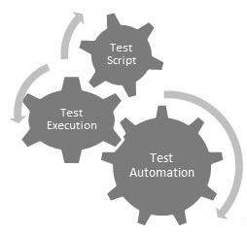Automation testing, which is also known as Test Automation, is when the tester writes scripts and uses another software to test the product. This process involves automation of a manual process. Automation Testing is used to re-run the test scenarios that were performed manually, quickly, and repeatedly.

Apart from regression testing, automation testing is also used to test the application from load, performance, and stress point of view. It increases the test coverage, improves accuracy, and saves time and money in comparison to manual testing.

**Software Testing – Methods**

There are different methods that can be used for software testing. This chapter briefly describes the methods available.

## Black-Box Testing :

The technique of testing without having any knowledge of the interior workings of the application is called black-box testing. The tester is oblivious to the system architecture and does not have access to the source code. Typically, while performing a black-box test, a tester will interact with the system's user interface by providing inputs and examining outputs without knowing how and where the inputs are worked upon.

The following table lists the advantages and disadvantages of black-box testing.

|  |  |
| --- | --- |
| **Advantages** | **Disadvantages** |
| * Well suited and efficient for large code segments. * Code access is not required. * Clearly separates user's perspective from the developer's perspective through visibly defined roles. * Large numbers of moderately skilled testers can test the application with no knowledge of implementation, programming language, or operating systems. | * Limited coverage, since only a selected number of test scenarios is actually performed. * Inefficient testing, due to the fact that the tester only has limited knowledge about an application. * Blind coverage, since the tester cannot target specific code segments or error-prone areas. * The test cases are difficult to design. |

## White-Box Testing :

White-box testing is the detailed investigation of internal logic and structure of the code. White-box testing is also called **glass testing** or **open-box testing**. In order to perform **white-box** testing on an application, a tester needs to know the internal workings of the code.

The tester needs to have a look inside the source code and find out which unit/chunk of the code is behaving inappropriately.

The following table lists the advantages and disadvantages of white-box testing.

|  |  |
| --- | --- |
| **Advantages** | **Disadvantages** |
| * As the tester has knowledge of the source code, it becomes very easy to find out which type of data can help in testing the application effectively. * It helps in optimizing the code. * Extra lines of code can be removed which can bring in hidden defects. * Due to the tester's knowledge about the code, maximum coverage is attained during test scenario writing. | * Due to the fact that a skilled tester is needed to perform white-box testing, the costs are increased. * Sometimes it is impossible to look into every nook and corner to find out hidden errors that may create problems, as many paths will go untested. * It is difficult to maintain white-box testing, as it requires specialized tools like code analyzers and debugging tools. |

## Grey-Box Testing :

Grey-box testing is a technique to test the application with having a limited knowledge of the internal workings of an application. In software testing, the phrase the more you know, the better carries a lot of weight while testing an application.

Mastering the domain of a system always gives the tester an edge over someone with limited domain knowledge. Unlike black-box testing, where the tester only tests the application's user interface; in grey-box testing, the tester has access to design documents and the database. Having this knowledge, a tester can prepare better test data and test scenarios while making a test plan.

|  |  |
| --- | --- |
| **Advantages** | **Disadvantages** |
| * Offers combined benefits of black-box and white-box testing wherever possible. * Grey box testers don't rely on the source code; instead they rely on interface definition and functional specifications. * Based on the limited information available, a grey-box tester can design excellent test scenarios especially around communication protocols and data type handling. * The test is done from the point of view of the user and not the designer. | * Since the access to source code is not available, the ability to go over the code and test coverage is limited. * The tests can be redundant if the software designer has already run a test case. * Testing every possible input stream is unrealistic because it would take an unreasonable amount of time; therefore, many program paths will go untested. |

## A Comparison of Testing Methods :

The following table lists the points that differentiate black-box testing, grey-box testing, and white-box testing.

|  |  |  |
| --- | --- | --- |
| **Black-Box Testing** | **Grey-Box Testing** | **White-Box Testing** |
| The internal workings of an application need not be known. | The tester has limited knowledge of the internal workings of the application. | Tester has full knowledge of the internal workings of the application. |
| Also known as closed-box testing, data-driven testing, or functional testing. | Also known as translucent testing, as the tester has limited knowledge of the insides of the application. | Also known as clear-box testing, structural testing, or code-based testing. |
| Performed by end-users and also by testers and developers. | Performed by end-users and also by testers and developers. | Normally done by testers and developers. |
| Testing is based on external expectations - Internal behavior of the application is unknown. | Testing is done on the basis of high-level database diagrams and data flow diagrams. | Internal workings are fully known and the tester can design test data accordingly. |

**IMPLEMENTATION AND MAINTENANCE:**

This is the last stage in SDLC. The project is implemented for the client in real environment where it can be used. The project then runs in the real environment with all the real process executed by the user. The implementation includes the proper development of the project on to the server. After the real execution of the project under the real circumstances by the user, some loop holes may be uncovered. It is also possible that after some time the user may request some changes or report some problems in the working system. The maintenance of a project means updating the project for the required changes in the implemented system.

**PHYSICAL DESIGN**

**ADMIN PART :**

The first part that has been developed is the admin part since the administrator is going to enter, update and delete values from the database.

So the first is the **Admin Login part** :

1. Below is the **Admin Login Page(‘Admin_login.php’).** All the admin related pages has been kept in a separate folder called ‘admin’.

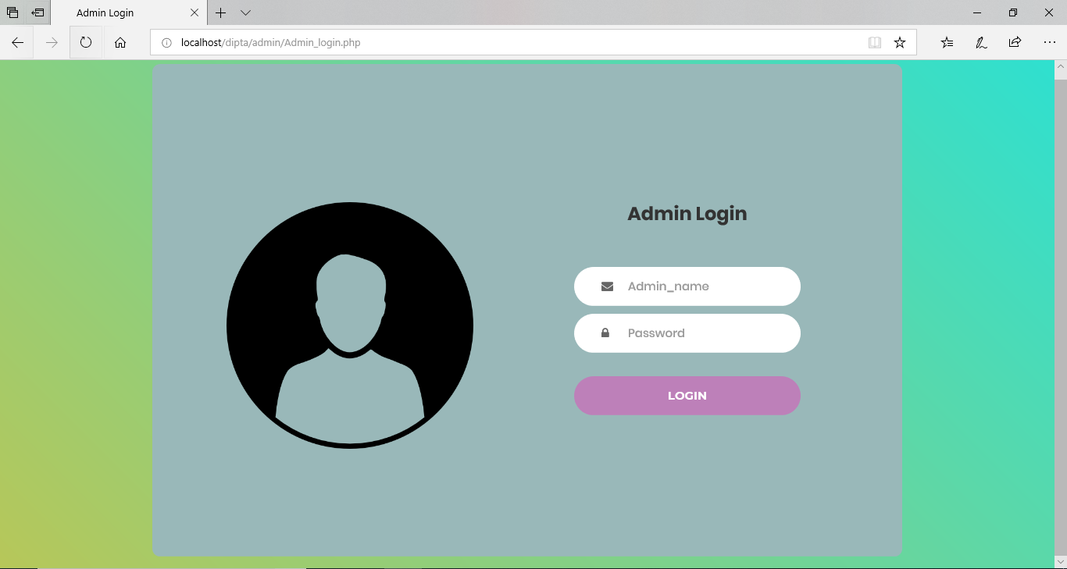

1. The UserID and Password to login into the administrator account is ‘admin’ and ‘admin’.

If the admin enters the wrong userid or password by mistake he/she is denied access to the admin account and the admin is redirected to **‘adminerror.jsp’ page** where the error message is displayed.

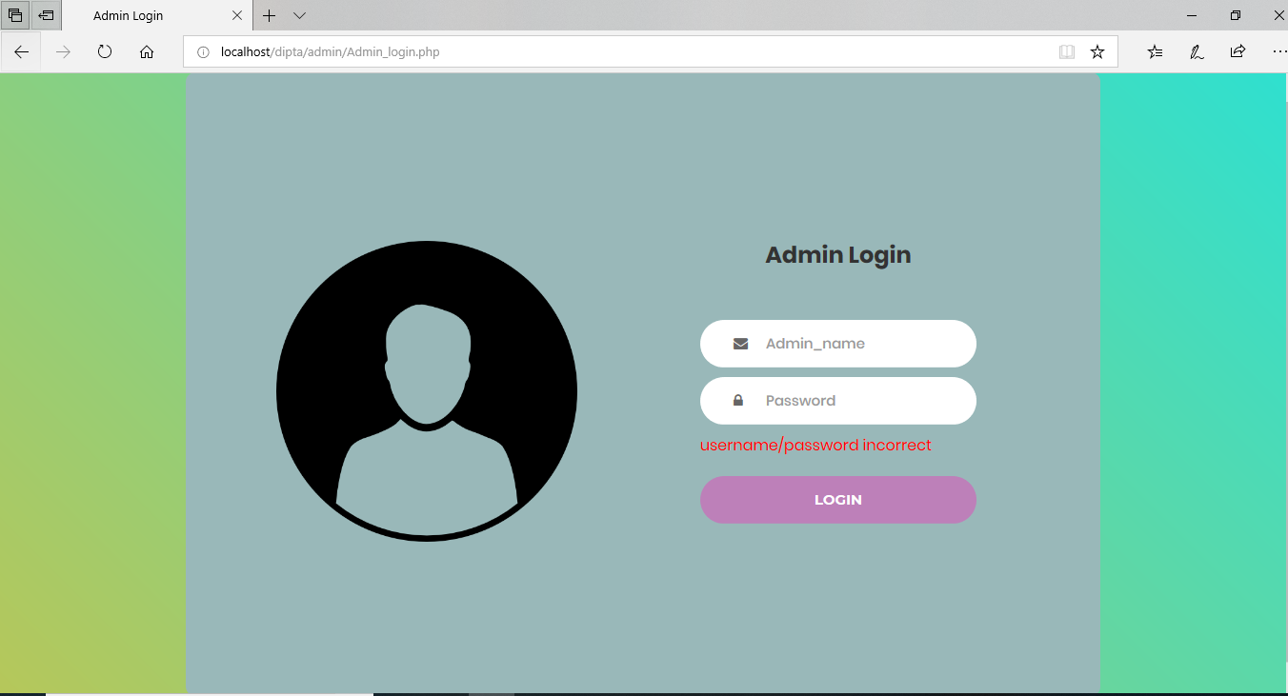

1. Now if the administrator enters the correct UserID and Password i.e., ‘admin’ and ‘admin’ he/she is granted access to the admin account and is redirected to the **‘admin_dashboard.php’ page** where he/she can perform all admin related tasks such as adding new hotels, editing/updating the details of the exising hotels and deleting hotels. The admin can also view all the rooms that have been booked by different users in different hotels.

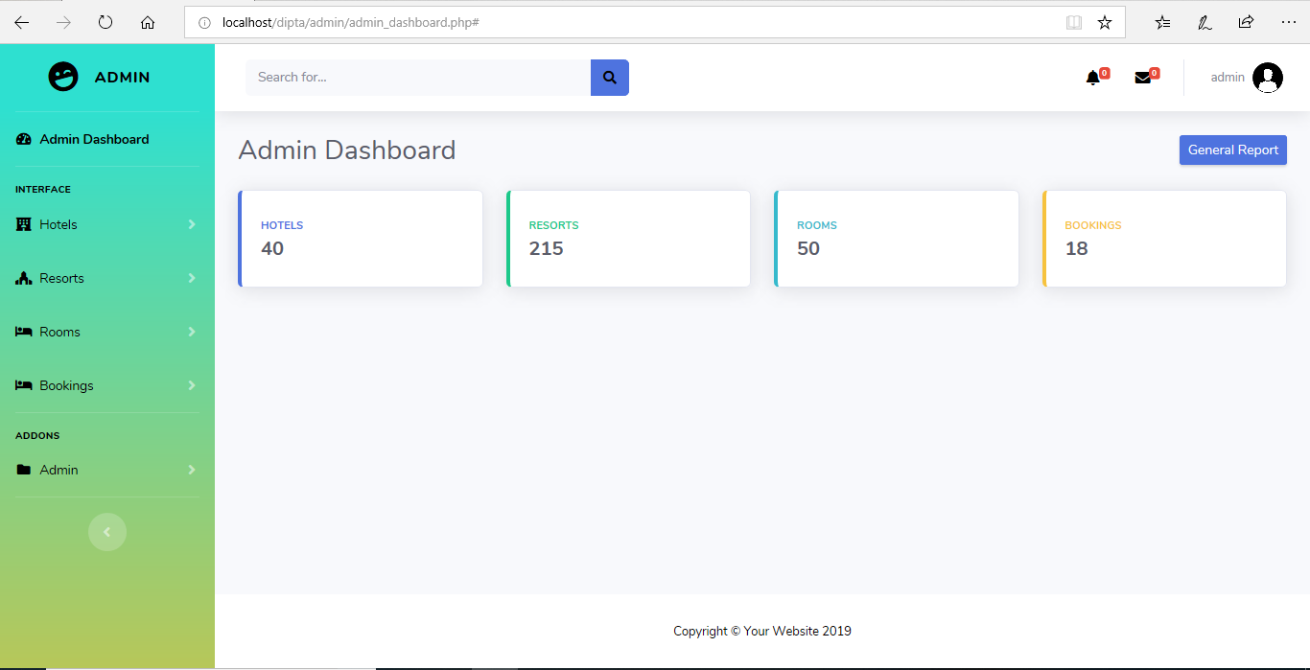

1. After finishing all the tasks if admin wants to ‘LogOut’ of his account he/she can click on the ‘LogOut’ link. Clicking on the **‘LogOut’ link** will get the admin logged out from his account and he will be directed to the login page**(‘Admin_login.php’)** again.

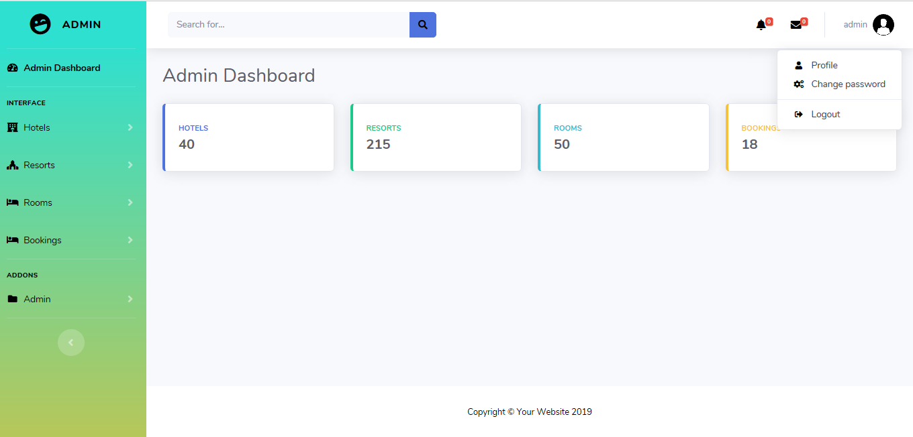

**TASKS CARRIED OUT BY THE ADMIN**

**Adding/Updating/Deleting Hotels**

* 1. Now if the admin wants to add a new hotel in the database he has to click on the **‘Add Hotels’ link** present on the right of the **‘admin_dashboard.php’** page.

After clicking on the ‘Add Hotels’ link **‘add_hotel.php’ page** opens where the admin has to add the details of the hotel with picture which he/she wants to add.

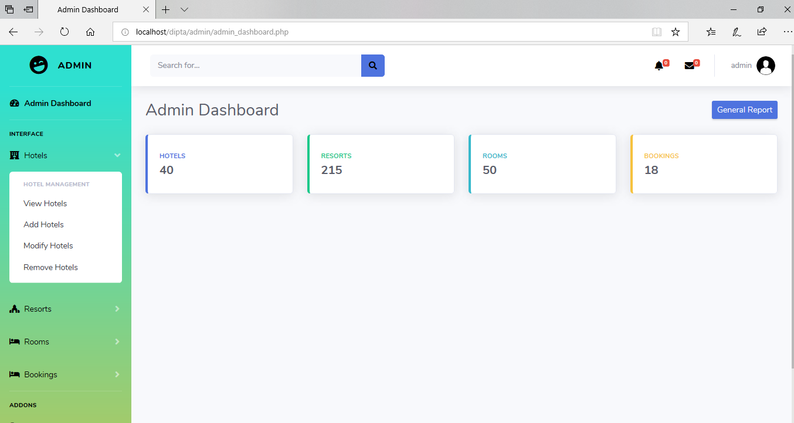

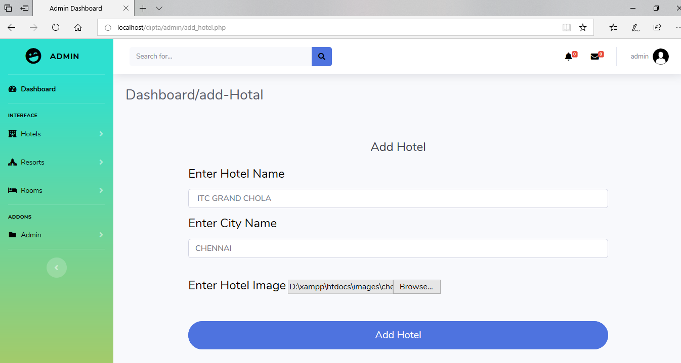

* 1. After clicking on ‘Add Hotel’ all the details that the admin has entered gets inserted into the database ‘dipta’ and all the data’s so entered are displayed in a page **‘view_hotel.php’.**

The ‘**view_hotel.php**’ page displays all the hotels present in the database.

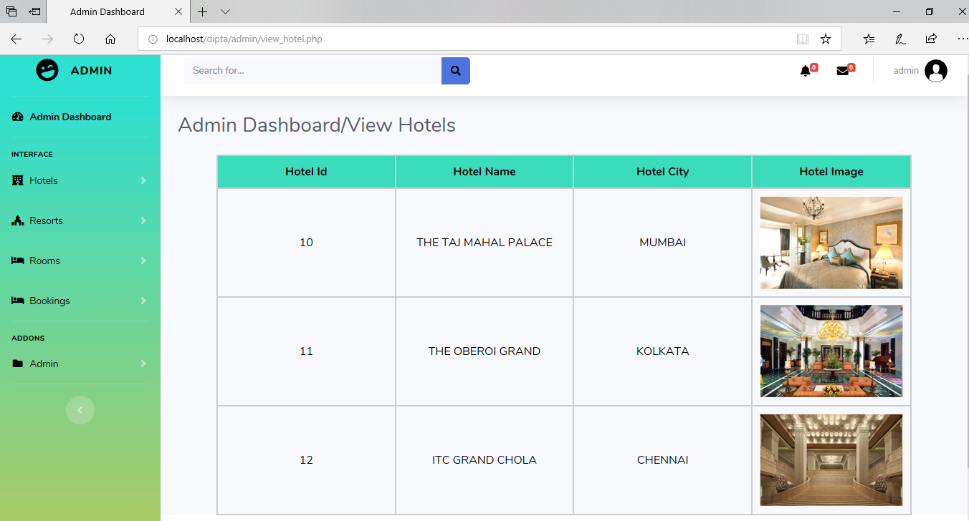

There are edit and delete buttons at the left navbar – **‘Modify Hotels’** and **‘Remove Hotels’**. By clicking on the ‘**Modify Hotels**’ button the admin can update/edit the previous details of the hotels and by clicking on the ‘**Remove Hotels**’ button the admin can permanently remove the record of the hotel. There will be no existence of the hotel in the database if it is deleted by admin.



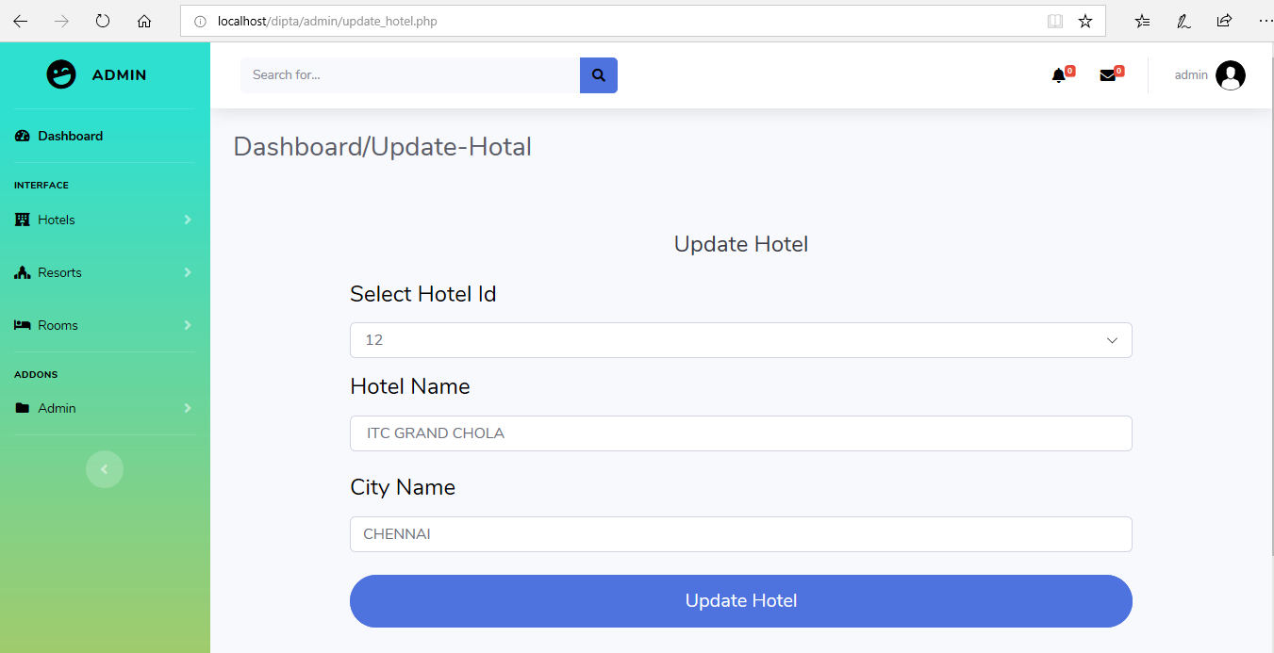

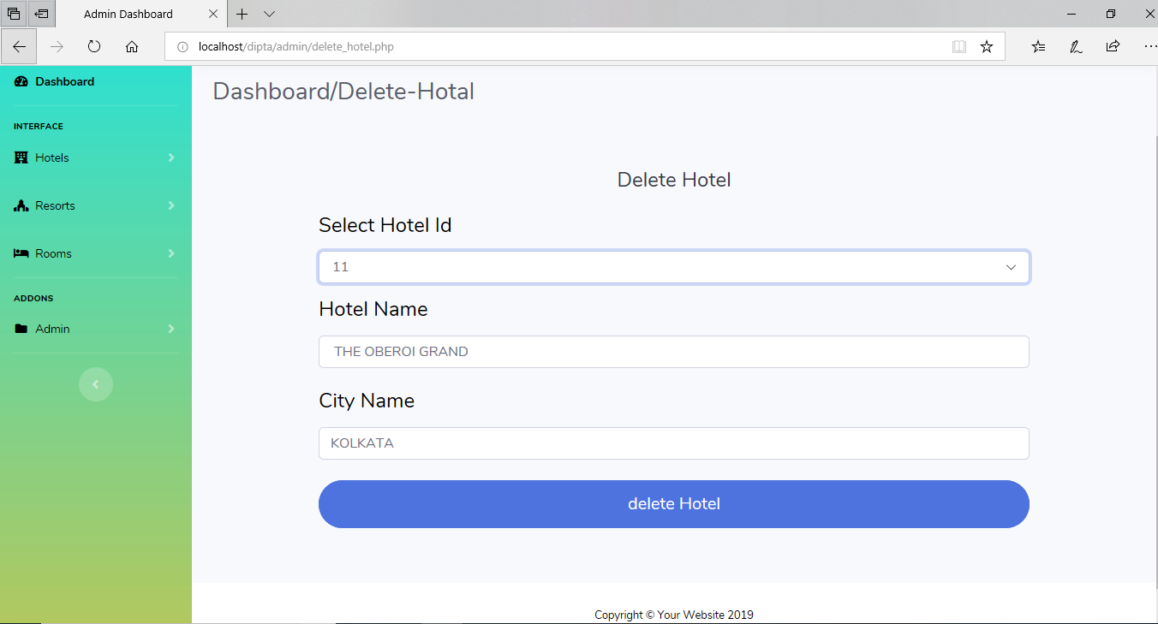

**Add/View/Editing/Deleting the details of rooms**

1. Now if the admin wants to add a new hotel room of a hotel in the database he has to click on the **‘Add Rooms’ link** present on the right of the **‘admin_dashboard.php’** page. After clicking on the ‘Add Rooms’ link **‘add_room.php’ page** opens where the admin has to add the details of the hotel room with picture which he/she wants to add.

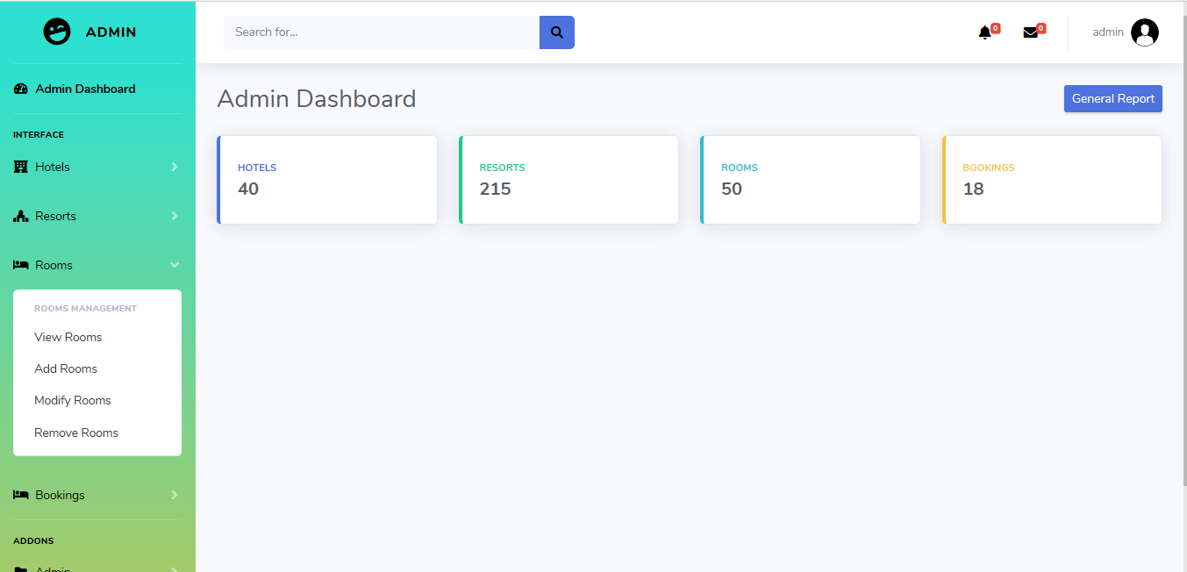

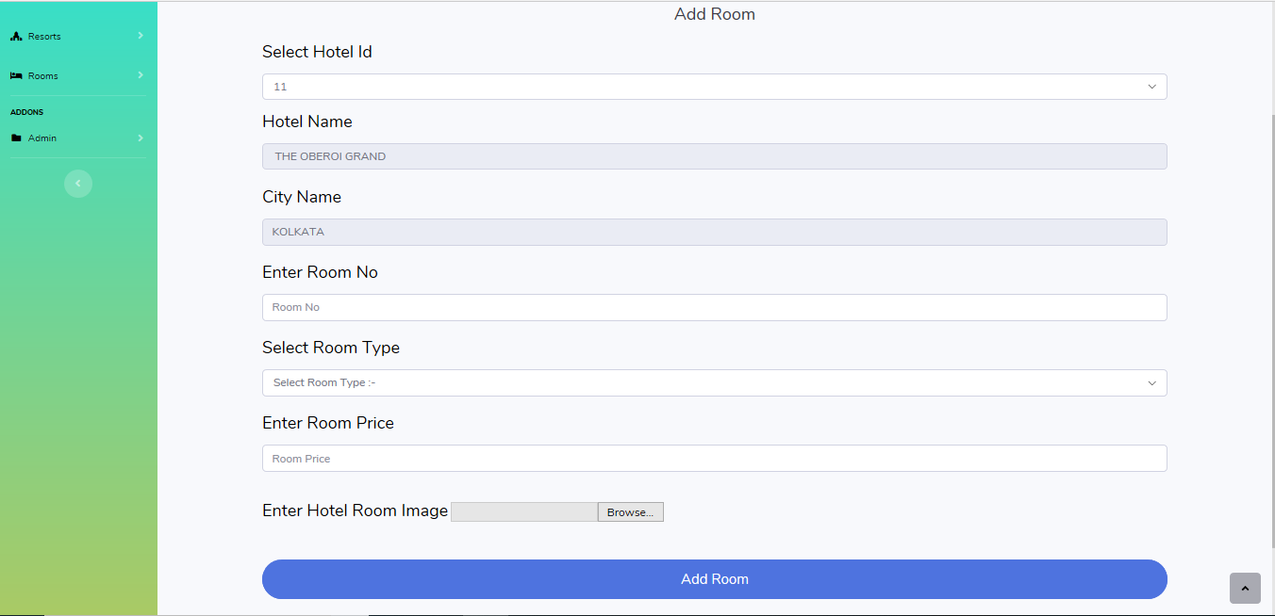

1. After clicking on ‘Add Room’ all the details that the admin has entered gets inserted into the database ‘dipta’ and all the data’s so entered are displayed in a page **‘view_room.php’.** The ‘**view_room.php**’ page displays all the hotel rooms present in the database.

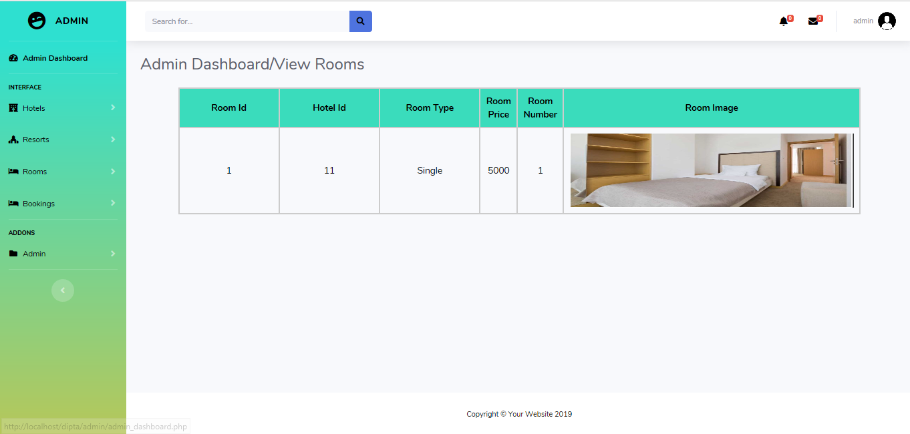

1. There are edit and delete buttons – **‘Modify Rooms’** and **‘Remove Rooms’**. By clicking on the ‘**Modify Rooms**’ button the admin can update/edit the previous details of the hotels and by clicking on the ‘**Remove Rooms**’ button the admin can permanently remove the record of the hotel room. There will be no existence of the hotel room in the database if it is deleted by admin.

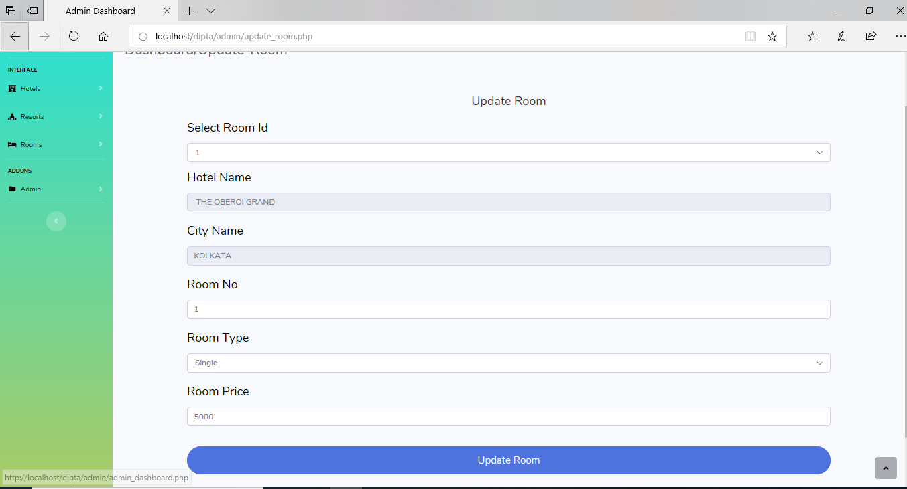

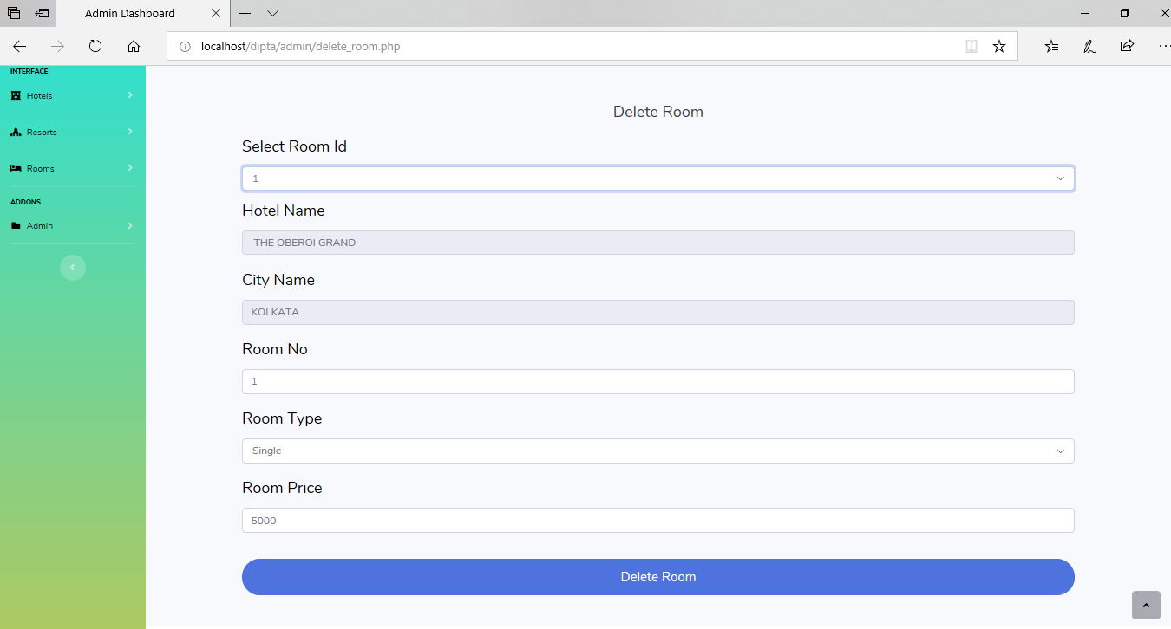

This is all about the Hotels part. The steps are same for the Resorts part so we didn’t show it.

**View Orders and Users**

Now if the admin wants to view the users and the order history from the database he has to click on the **‘Bookings’ and ‘Users’ link** present on the right of the **‘admin_dashboard.php’** page. After clicking on the ‘Bookings’ and ‘Users’ link **‘view_hotel_bookings.php’ page** opens The hotel booking orders and **‘view_resort_bookings.php’** opens The resort booking orders where the admin can see details of orders and **‘view_Users.php’** opens the users list.

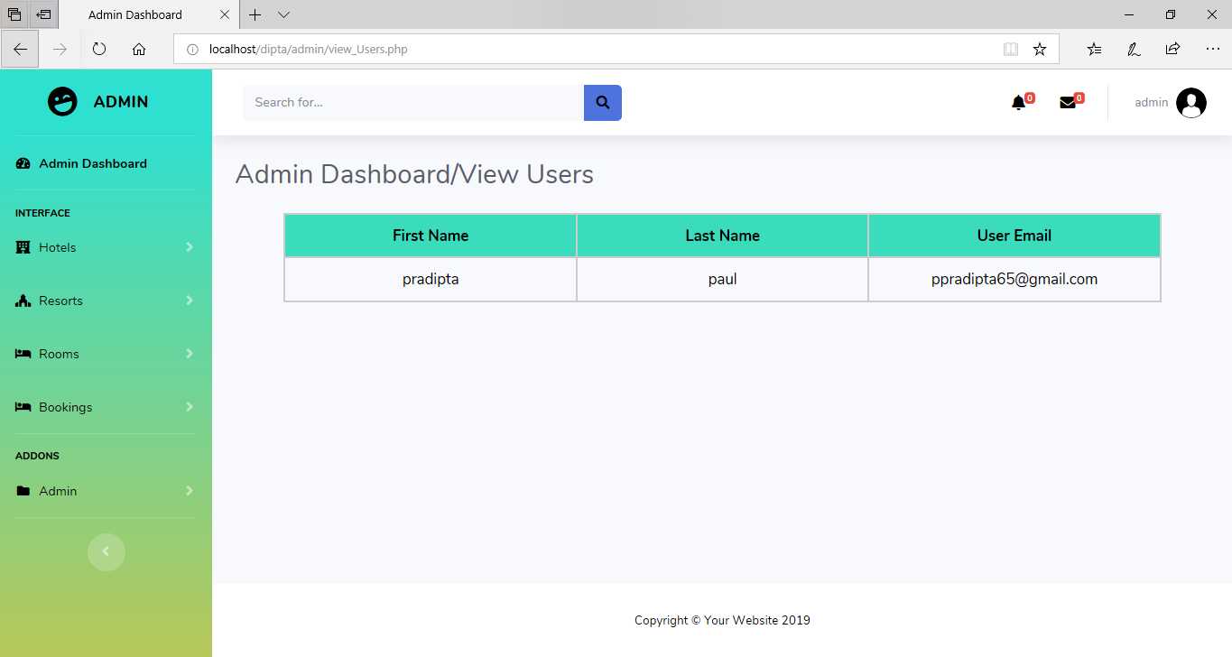

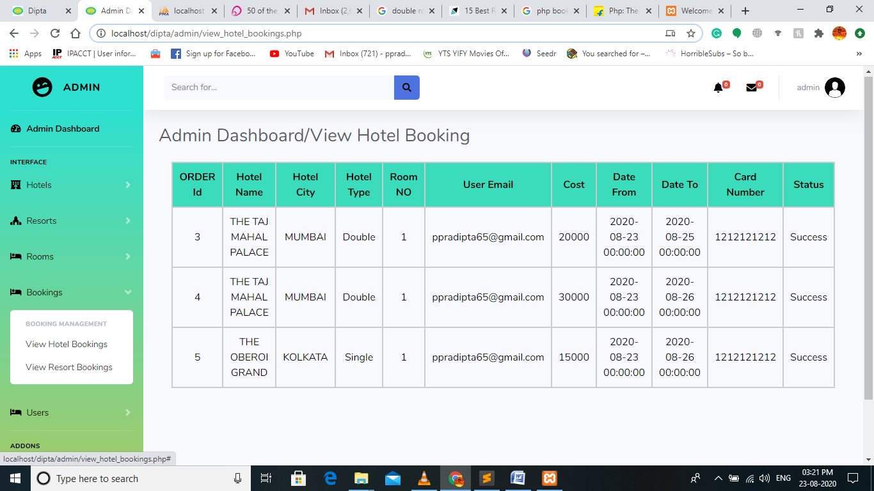

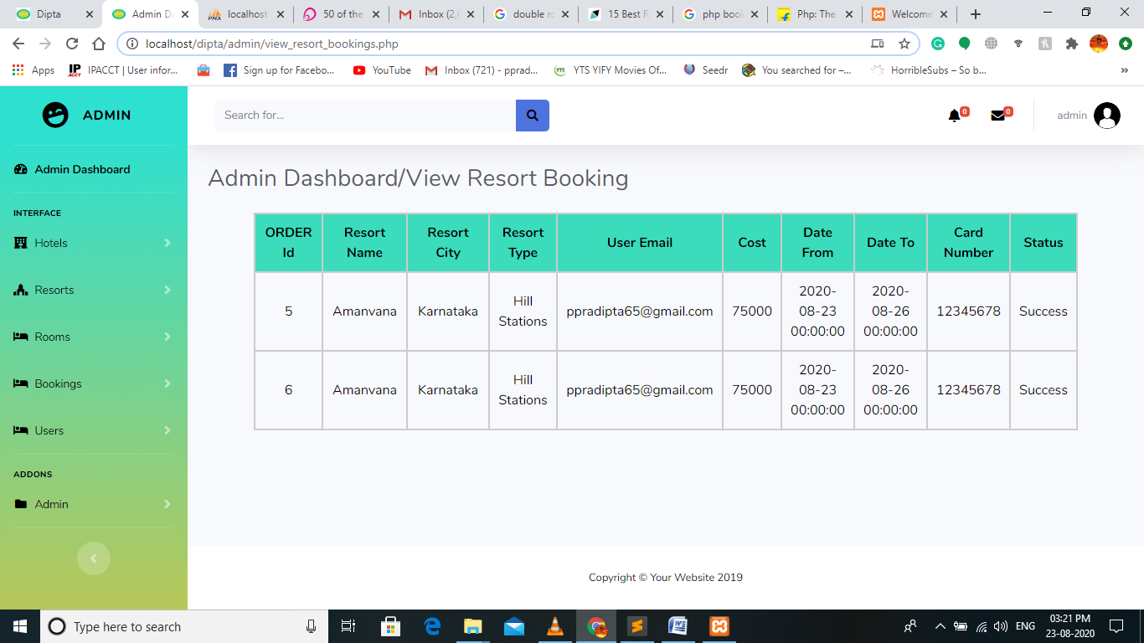

This is all about the ‘Admin’ part. Next is the User Interface part.

**USER INTERFACE PART**

1. The first come’s the Index page (index.jsp).

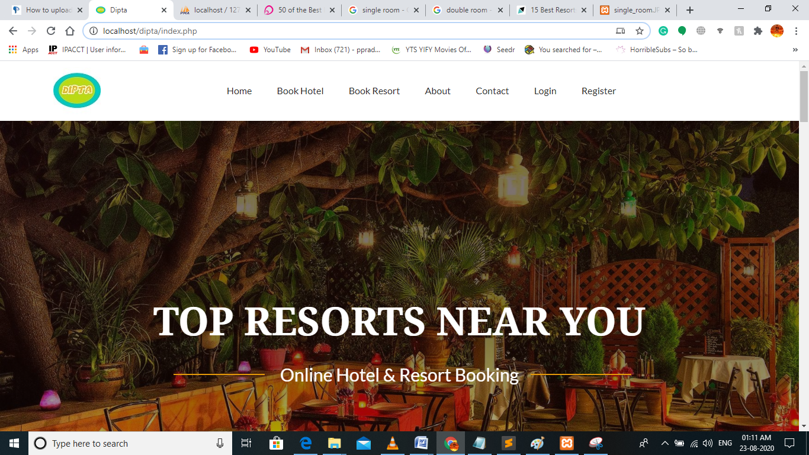

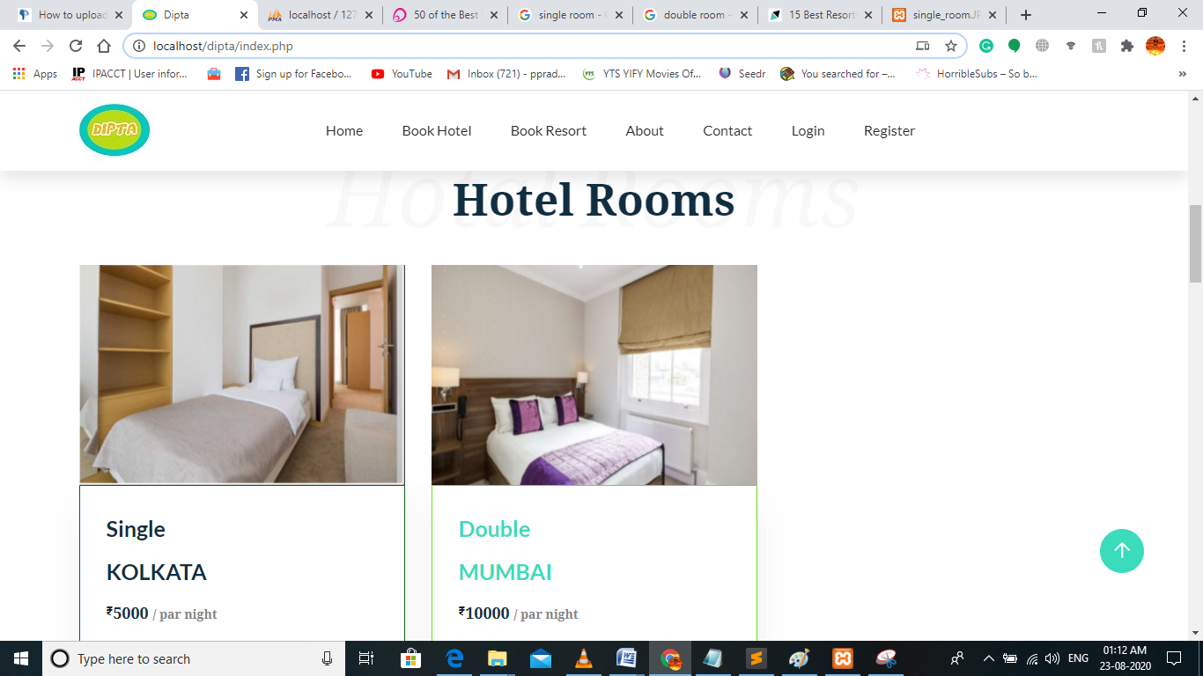

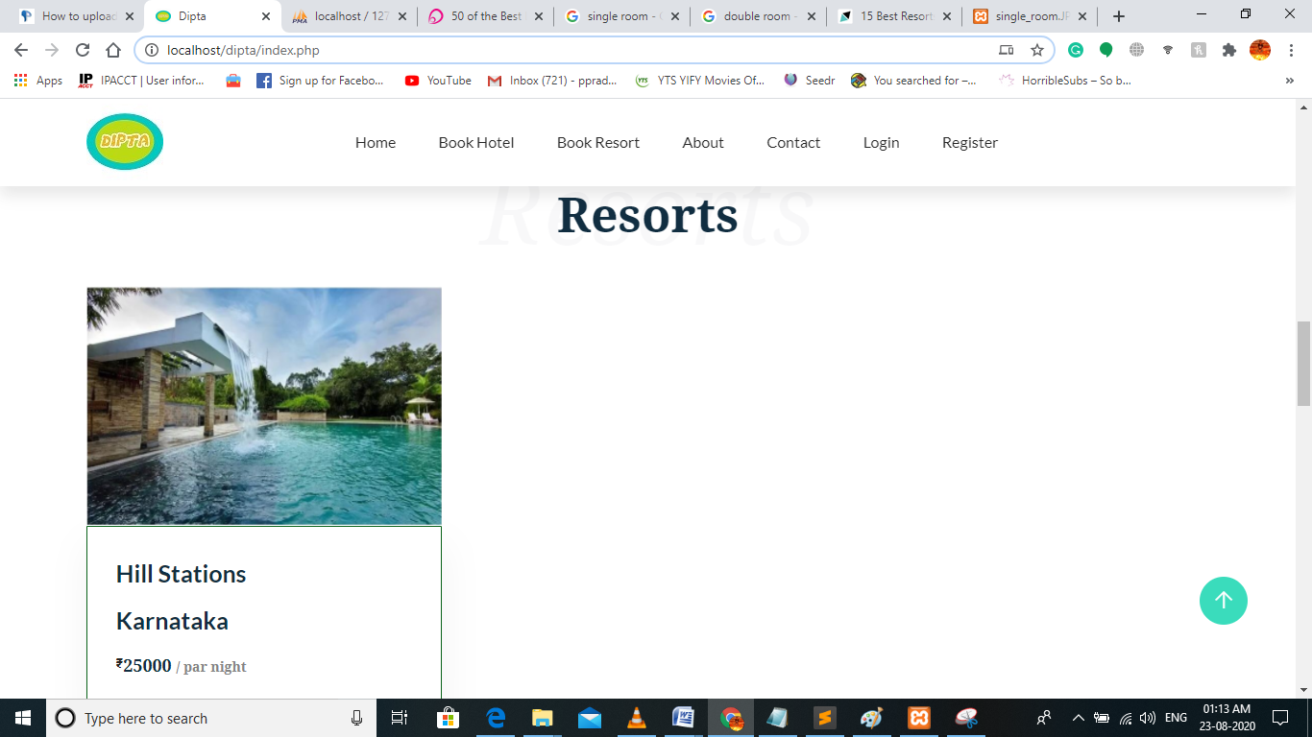

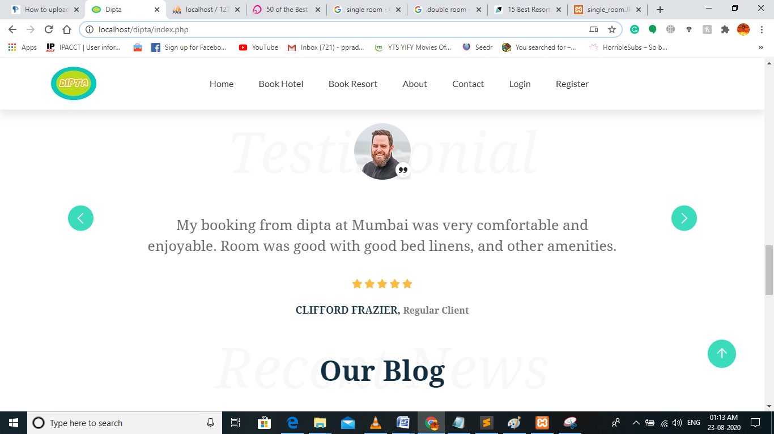

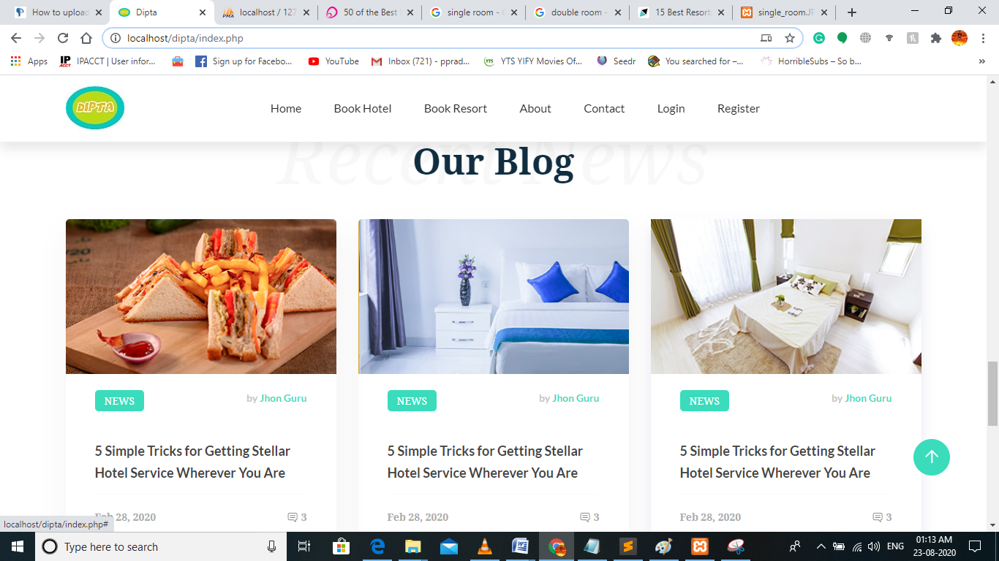

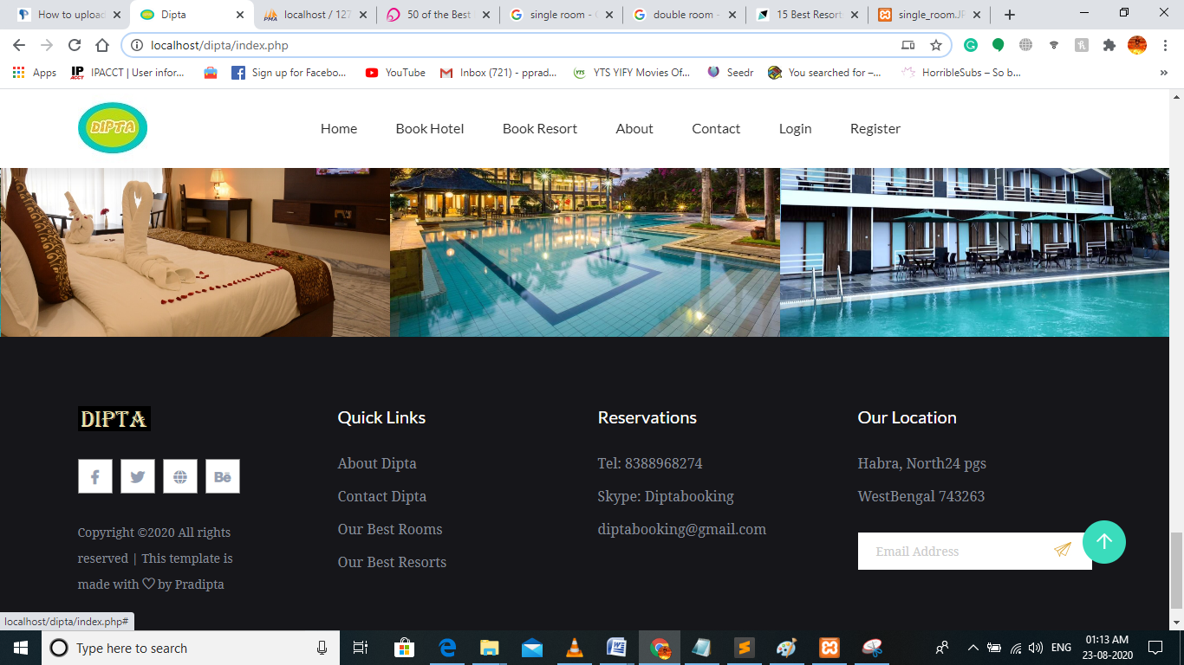

1. User can book hotel or resort after login or register. But user can contact us by using contact us (**contact.php**). Clicking on contact menu in **index.php** page takes the user to the **contact.php** page. In this page user can question us or tell us any query by filling a form where they have to write the message they want to ask, there name, email, subject. Also they can call us by the given phone number or mail us using the given email.

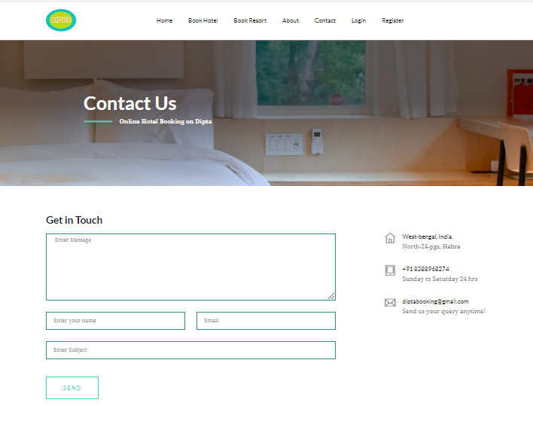

1. Clicking on the **‘About’** menu takes the user to **‘about.php’ page** which shows about the website and about its working principles.

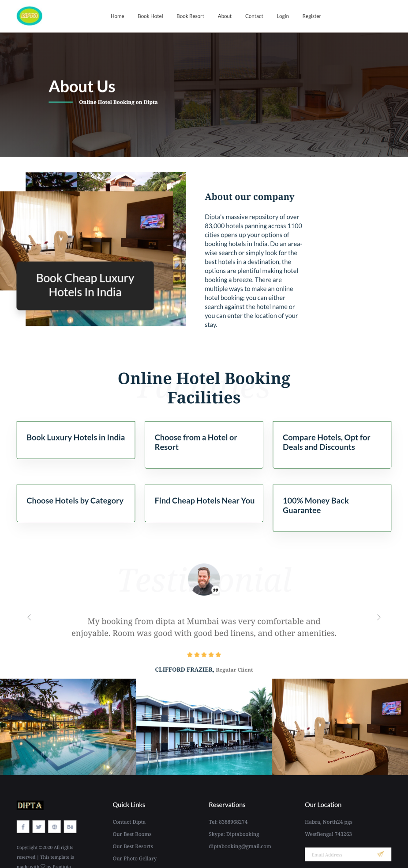

1. Clicking on the **‘view more’** in hotel section in the **‘index.php’** page takes the users to the **‘rooms.php’** page where different places and the number of hotels in those places are displayed. The same goes for the ‘RESORTS’. It takes the user to **‘resort.php’** page.

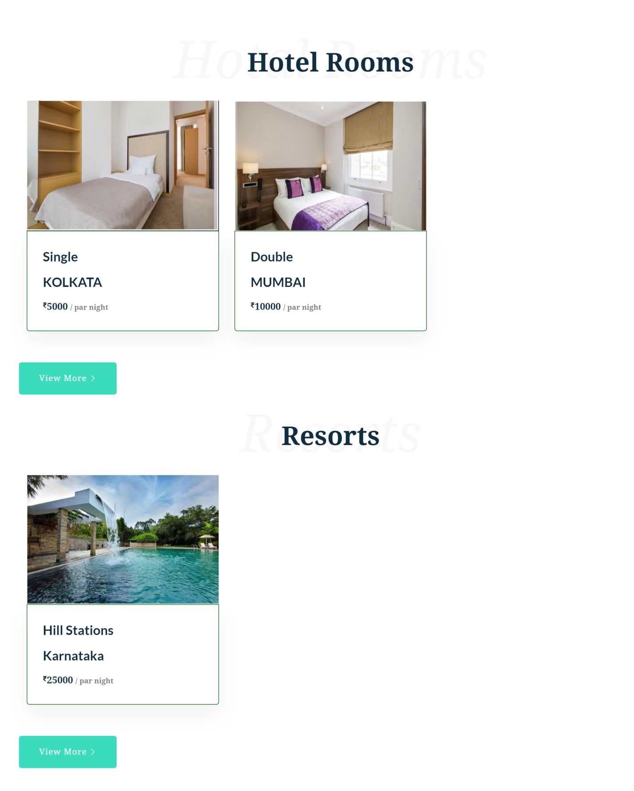

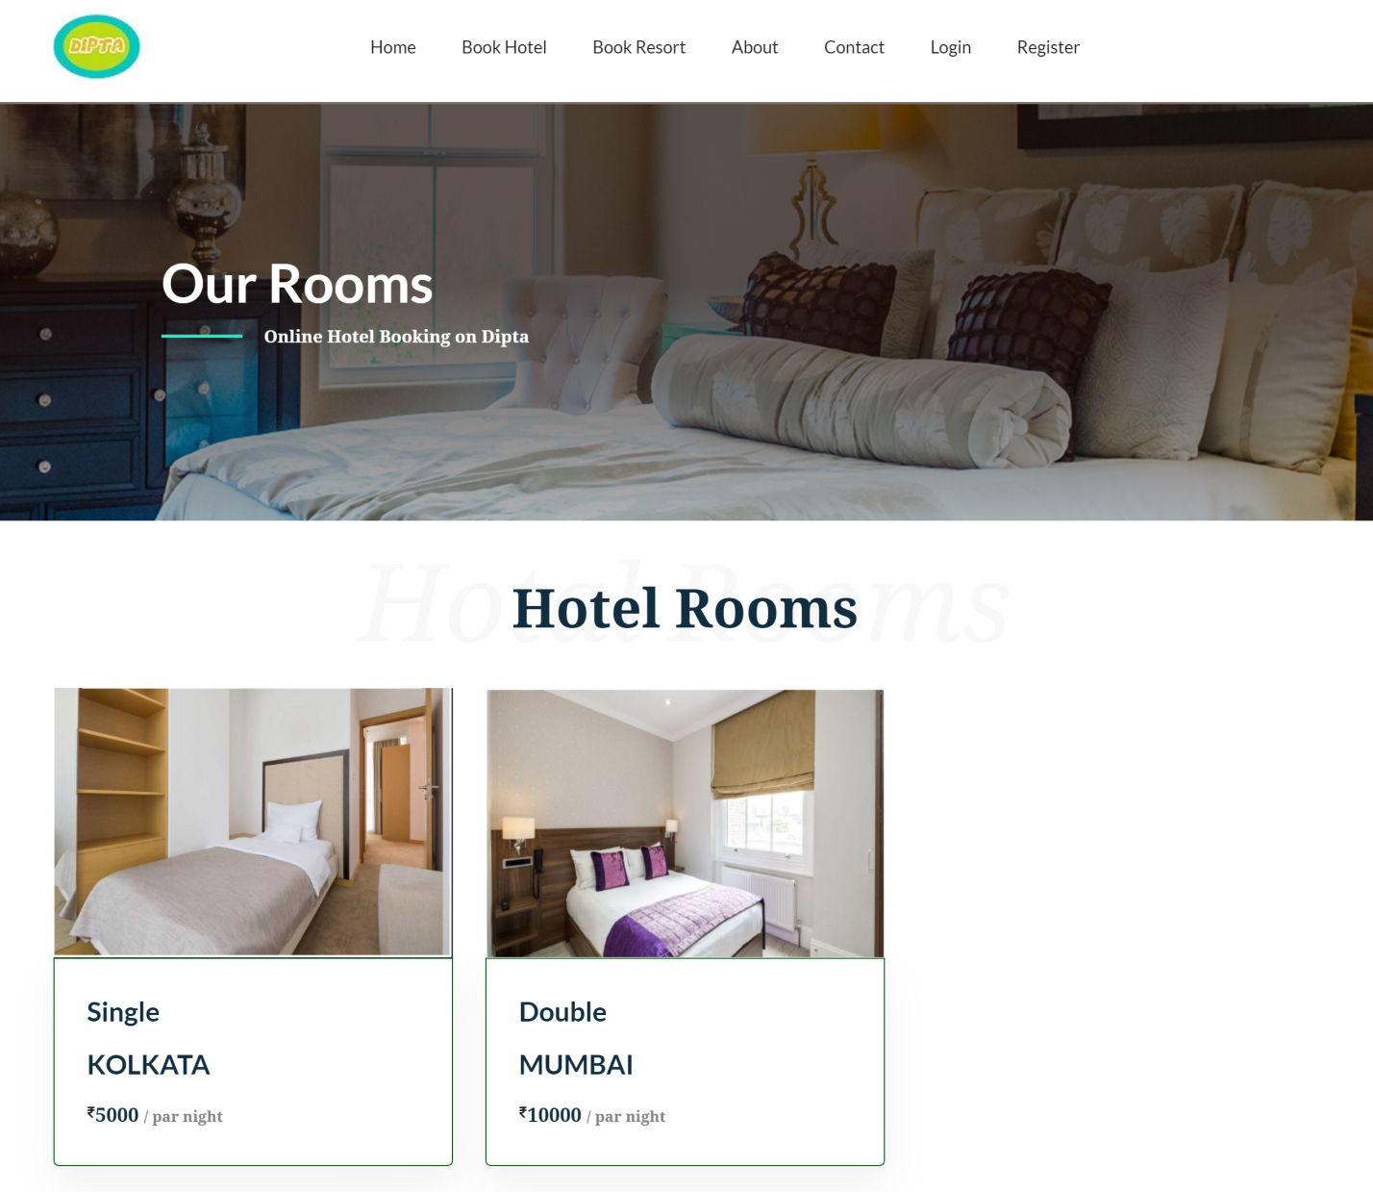

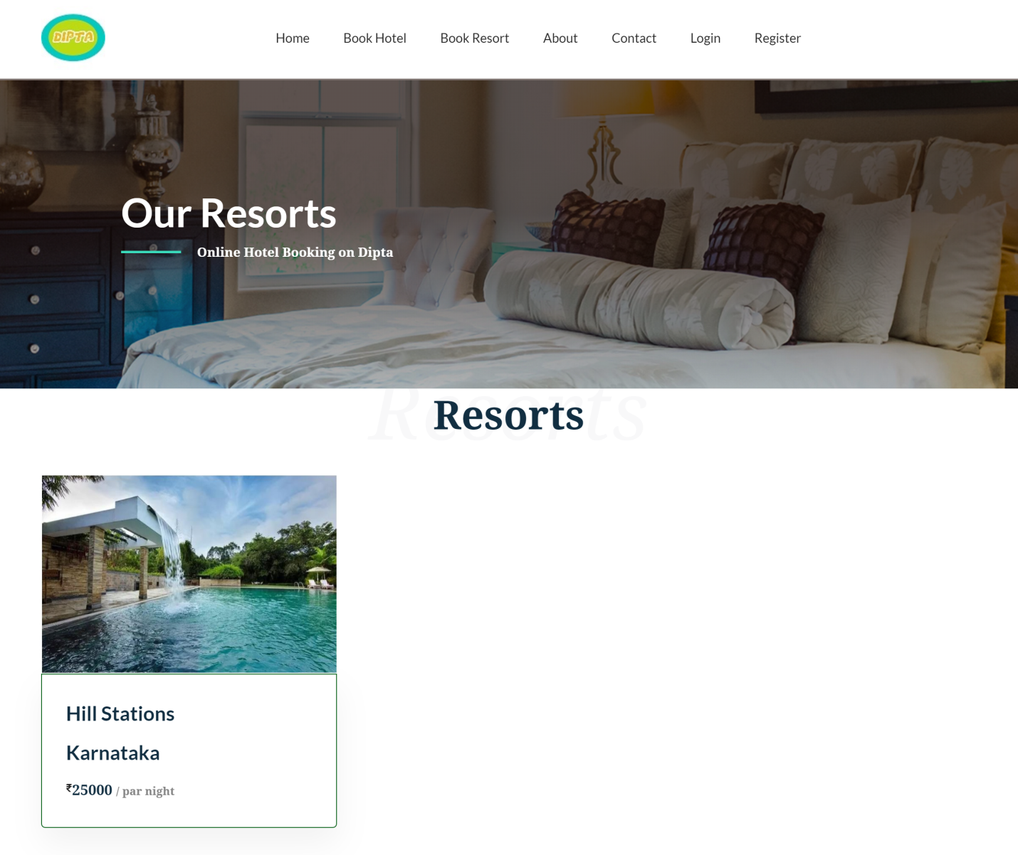

1. User has to register or login to book hotel or resort for register. For register user have to give their information like first name, last name, email, and password. If the user has already registered then they can login via registered email and password. They can register by clicking on **‘Register’** in navigation bar or login by clicking the **‘login’** in navigation bar. After clicking **‘Register’ ‘reg.php’** page open for register and clicking on **‘login’** the **‘login.php’** page will open for login.

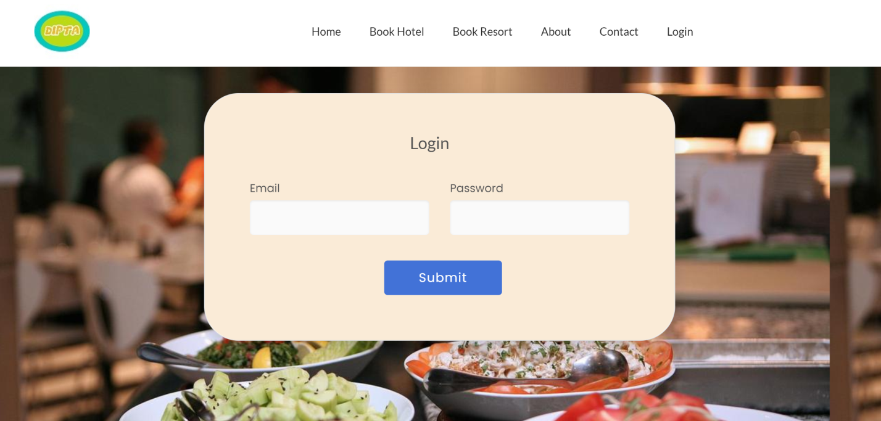

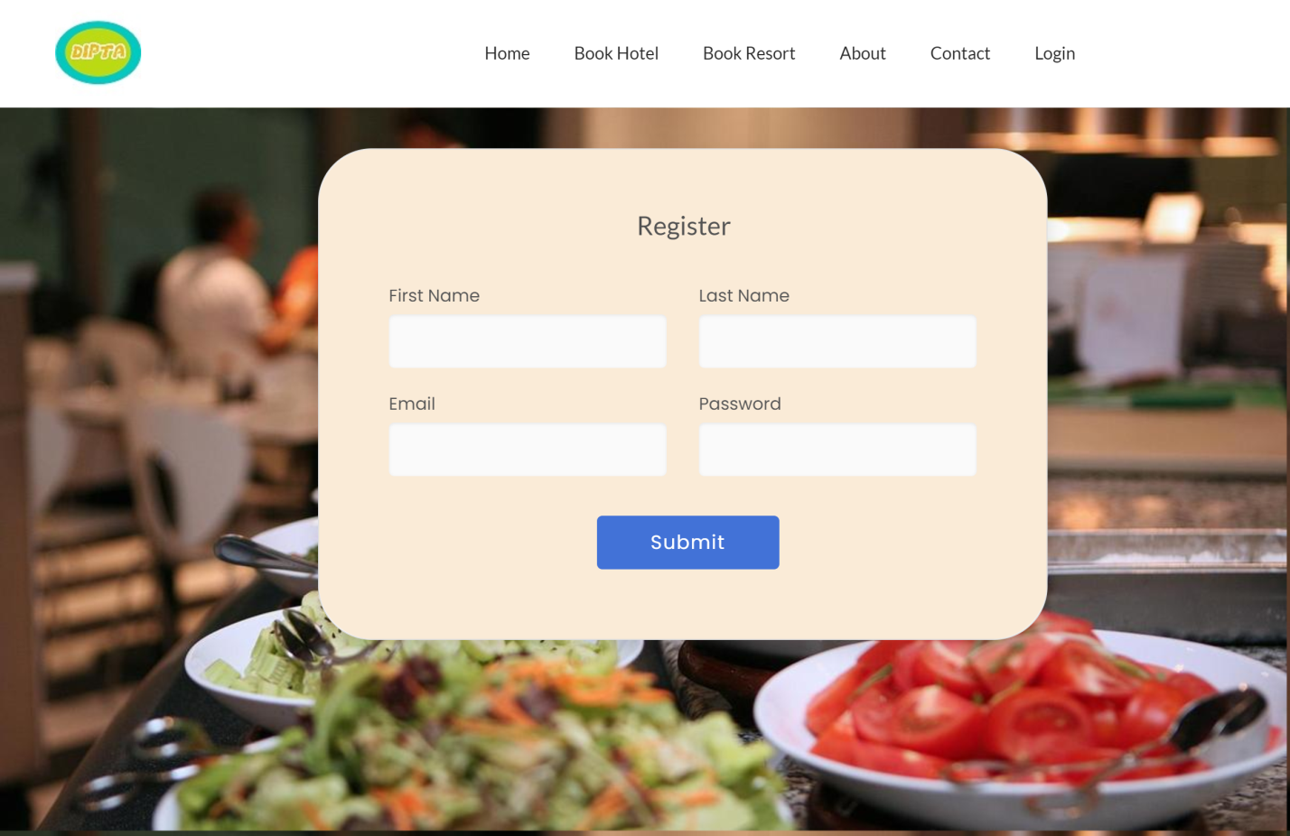

1. After login user redirected to the **‘home.php’** page there they can book hotel and resort. They can book hotel and resort directly by browsing or they can search for hotel and resort via name or via place.

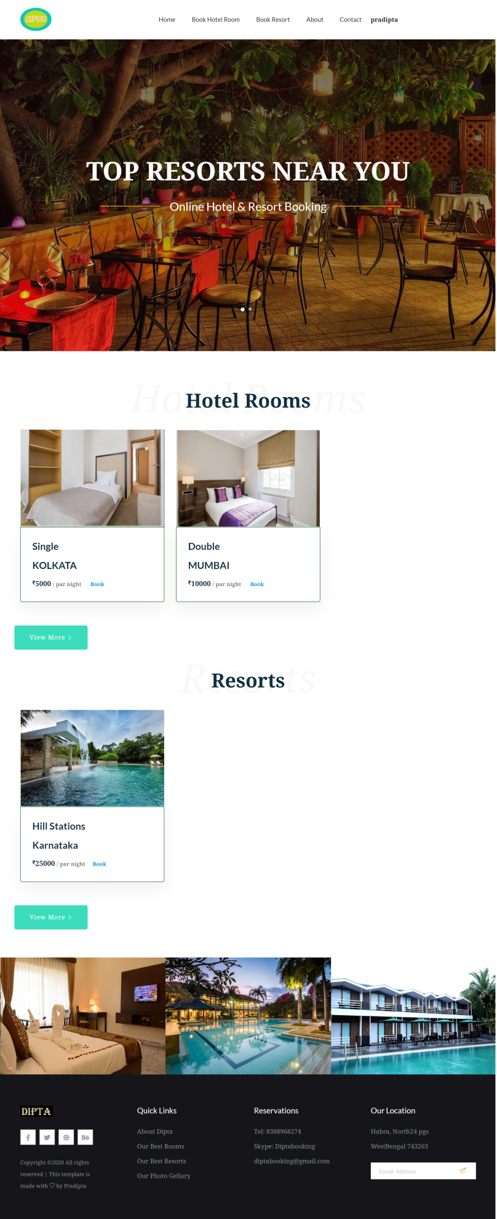

1. For hotel searching user drag the mouse on the **‘Book Hotel Room’** then two options will arise **‘Book By Hotel Name’** and **‘Book By City Name’**.



1. Clicking on **‘Book By Hotel Name’**, **‘book_by_hname.php’** page will open where user can select the hotel name they want to book. After selecting that, the details of the hotel will be displayed in the page. For book a in this hotel user have to press the **‘Check Rooms’** button the available room and its details will be displayed in the page. The user can book that room by clicking the **‘Book’**.

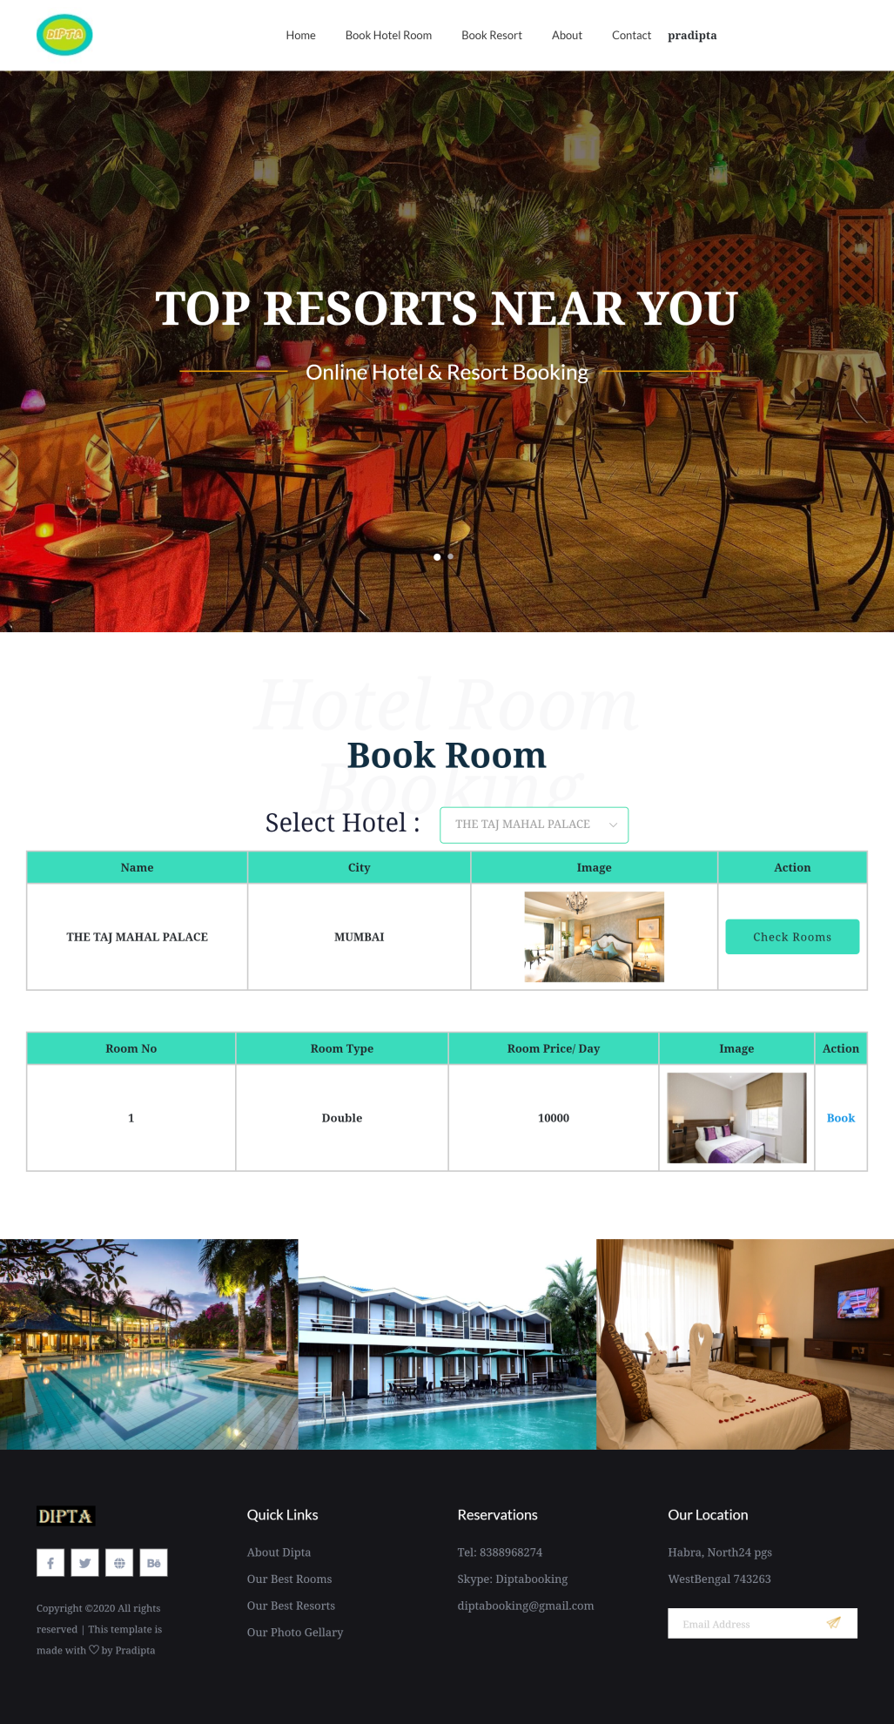

1. Clicking on **‘Book By City Name’**, **‘book_by_cname.php’** page will open where user can select the city of hotel they want to book. After selecting that, the details of the hotel will be displayed in the page. For book a in this hotel user have to press the **‘Check Rooms’** button the available room and its details will be displayed in the page. The user can book that room by clicking the **‘Book’**.

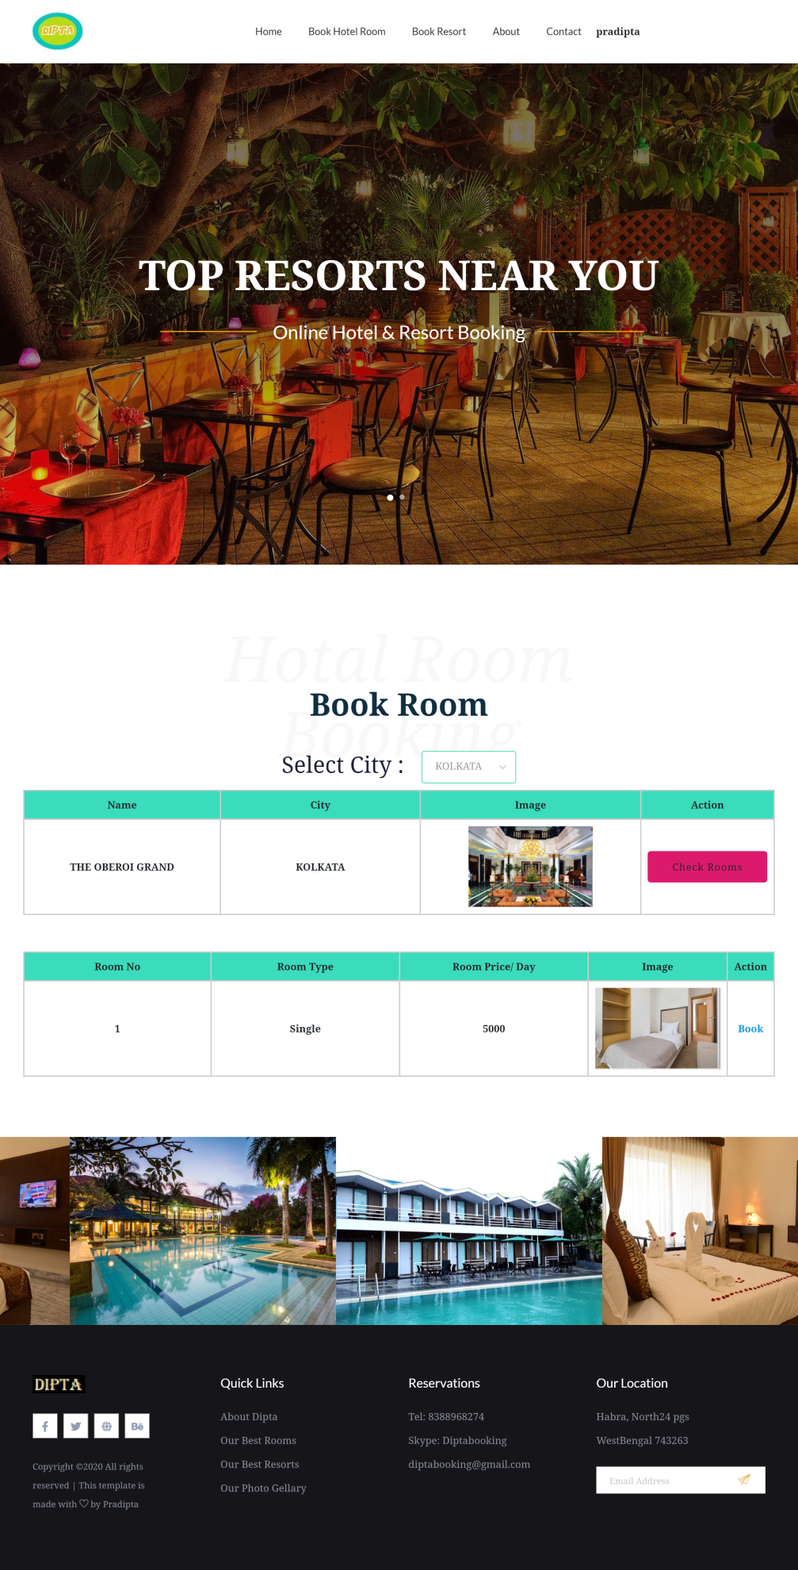

1. For Resort searching user drag the mouse on the **‘Book Resort** then two options will arise **‘Book By Name’** and **‘Book By City Name’**.

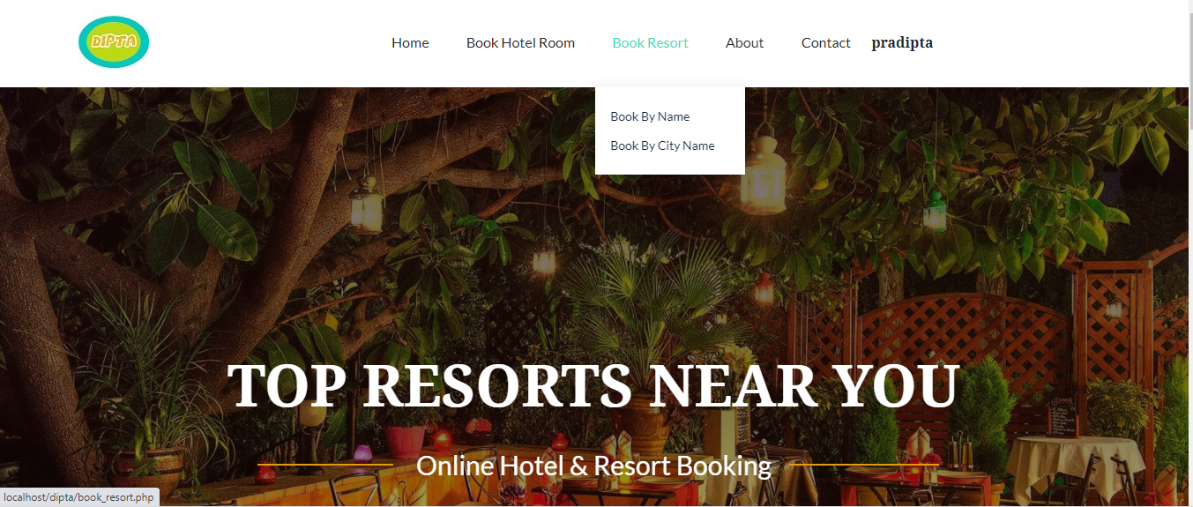

1. Clicking on **‘Book By Name’**, **‘book_by_rname.php’** page will open where user can select the resort name they want to book. After selecting that, the details of the resort will be displayed in the page. The user can book that resort by clicking the **‘Book’.**

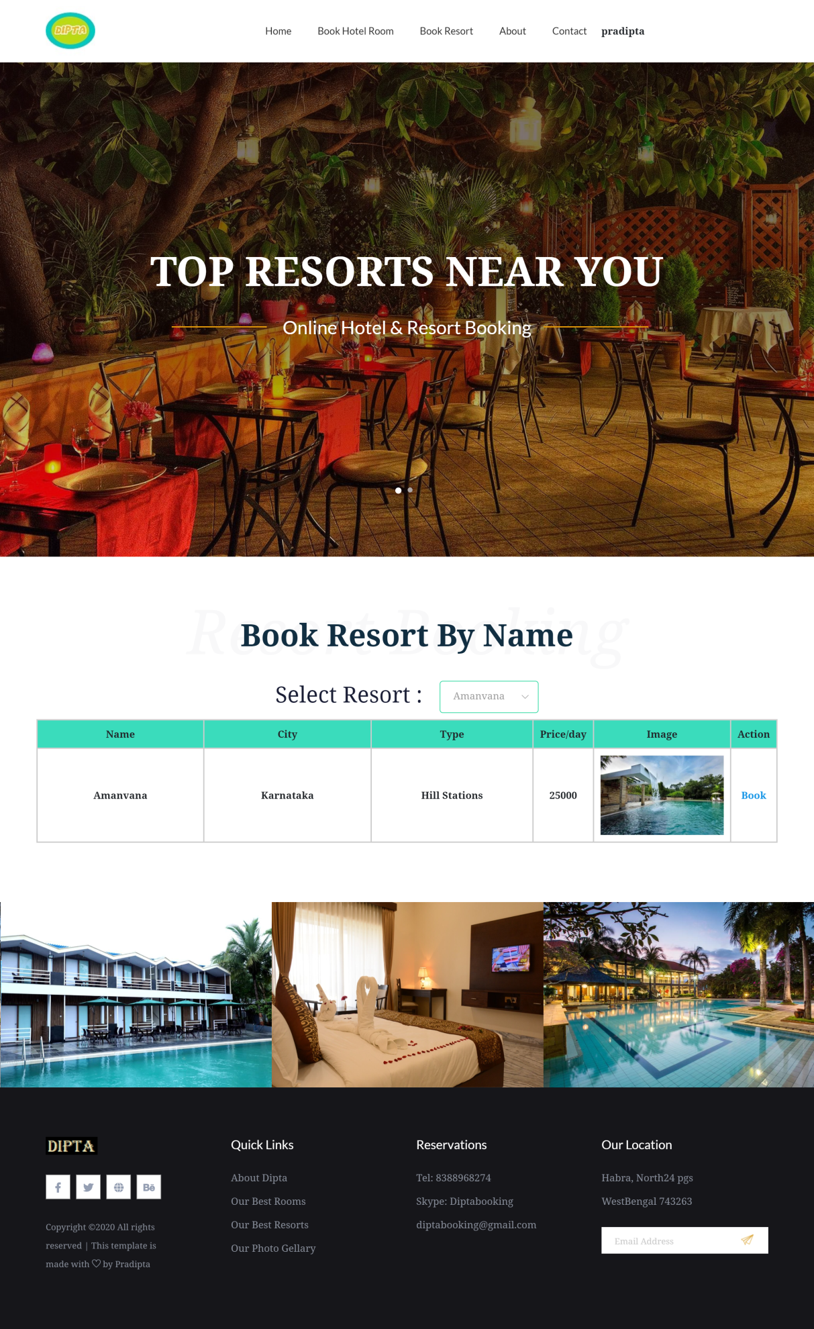

1. Clicking on **‘Book By City Name’**, **‘book_by_cnamer.php’** page will open where user can select the resort city name they want to book. After selecting that, the details of resorts will be displayed in the page. The user can book that resort by clicking the **‘Book’.**

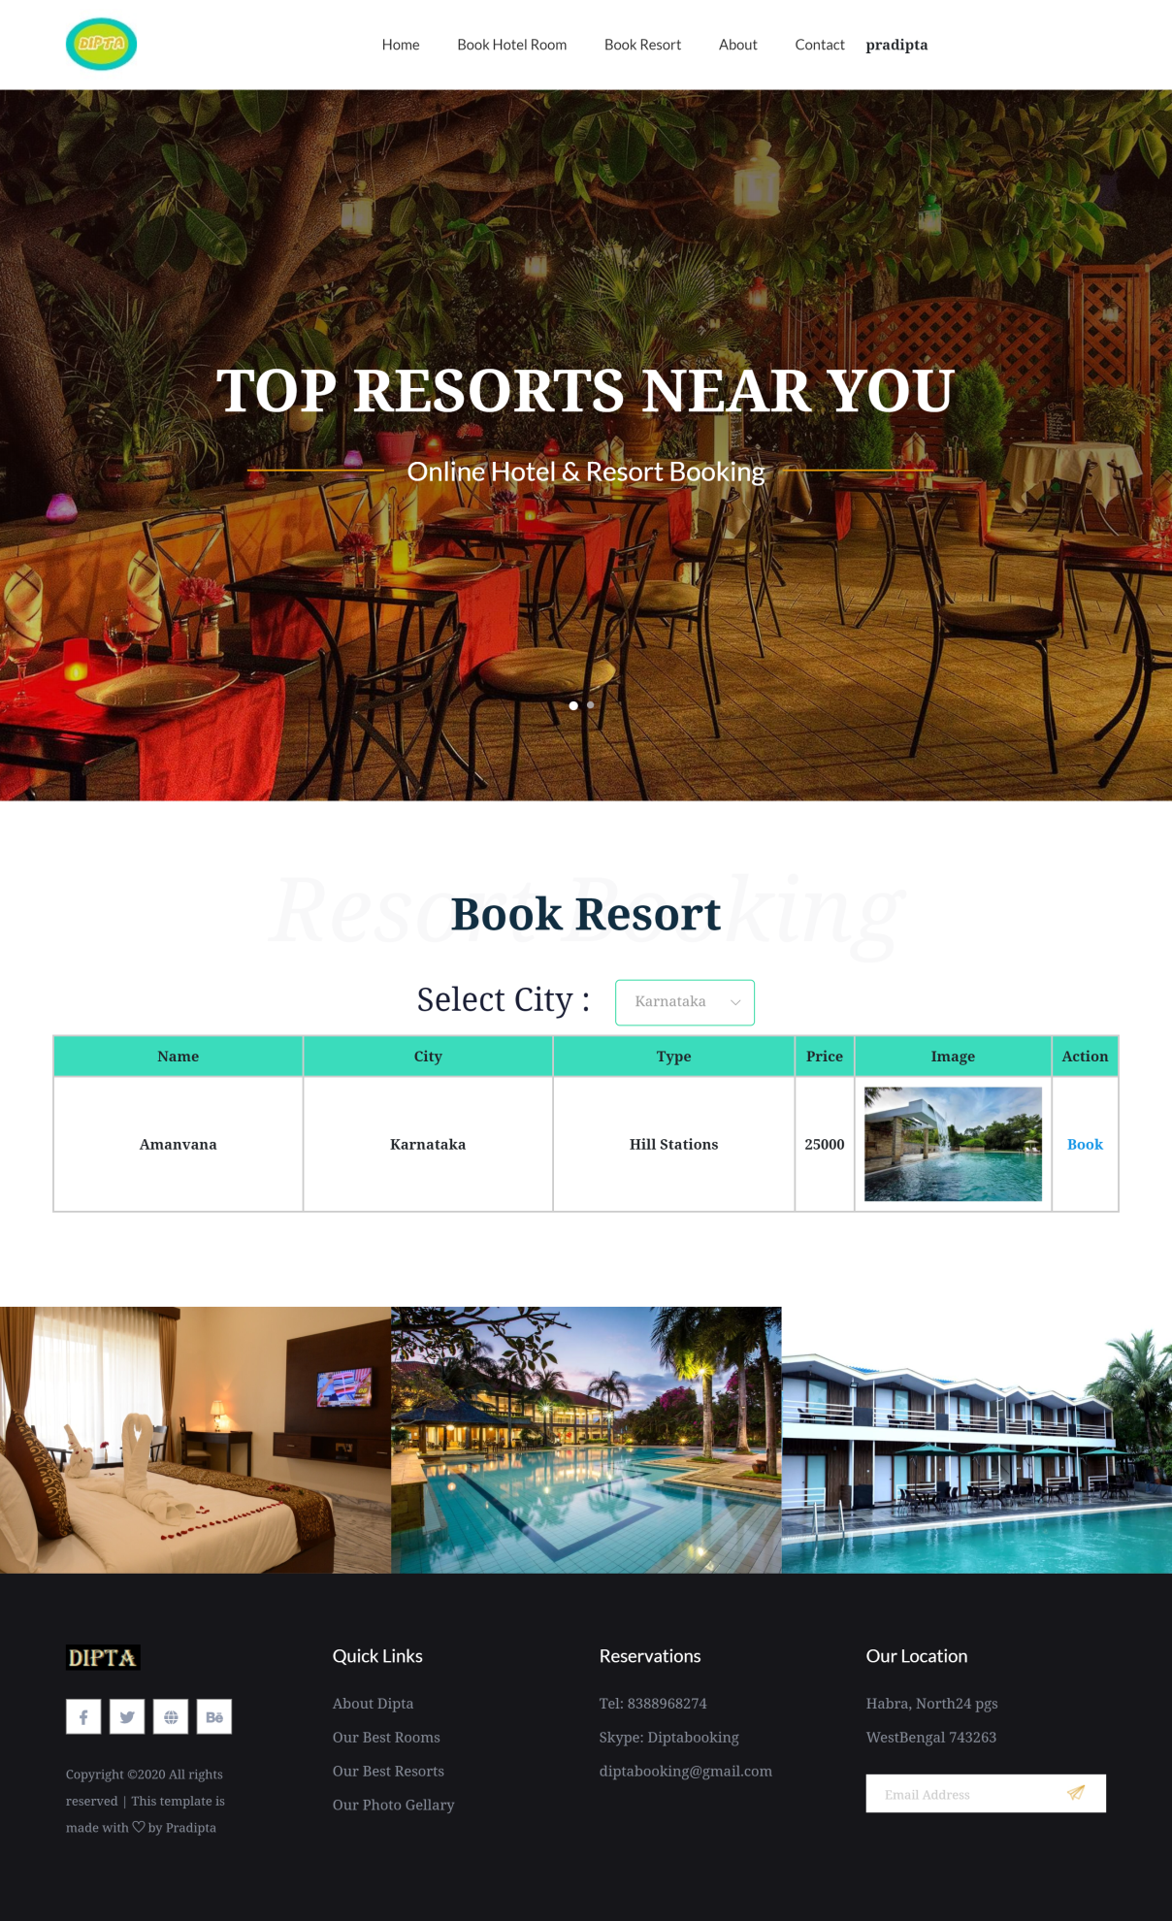

1. Booking and payment process of hotel is very simple. After clicking on **book** from **‘book_by_hname.php’** or **‘book_by_cname.php’** pages, itwill take users to the **‘book.php’** page where user can see all details of their booking hotel. There user have to select the **check-in date** and **check-out date** to book hotel. After selecting that the total amount and total number of days will display. Now for payment press the button **pay.** It will take user to the **‘pay.php’** page. Here user has to enter their debit or credit card number for payment. After giving the card number press submit button to payment. After submitting the booking will be done and **‘reciept.php’** will open which will show the status the booking. From this page user can go the home page.

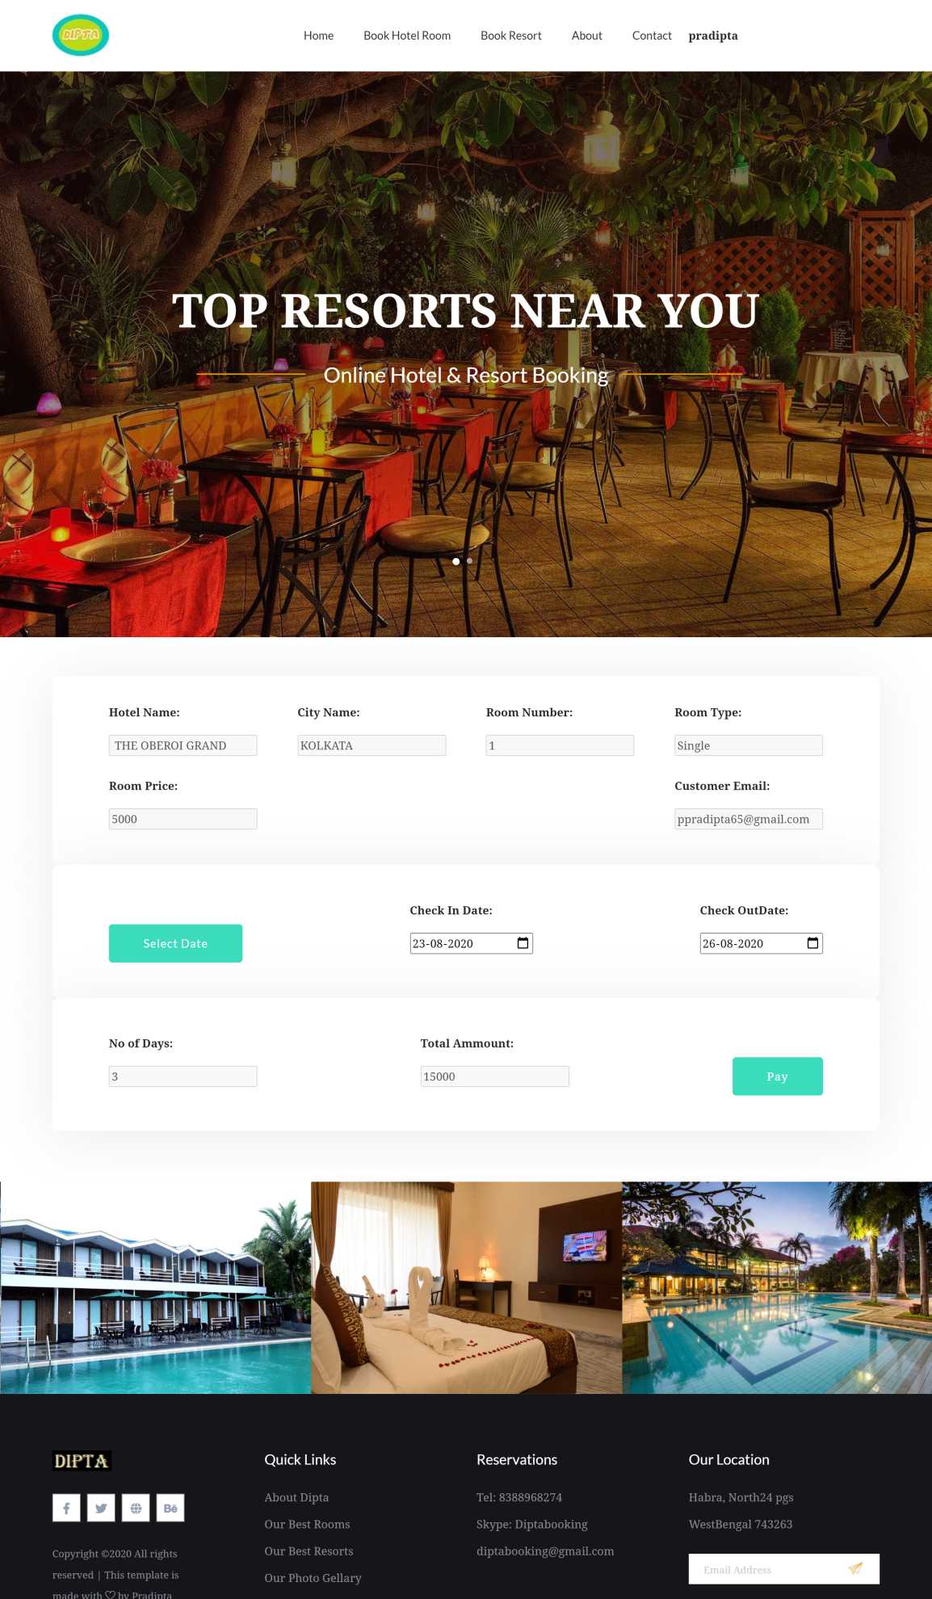

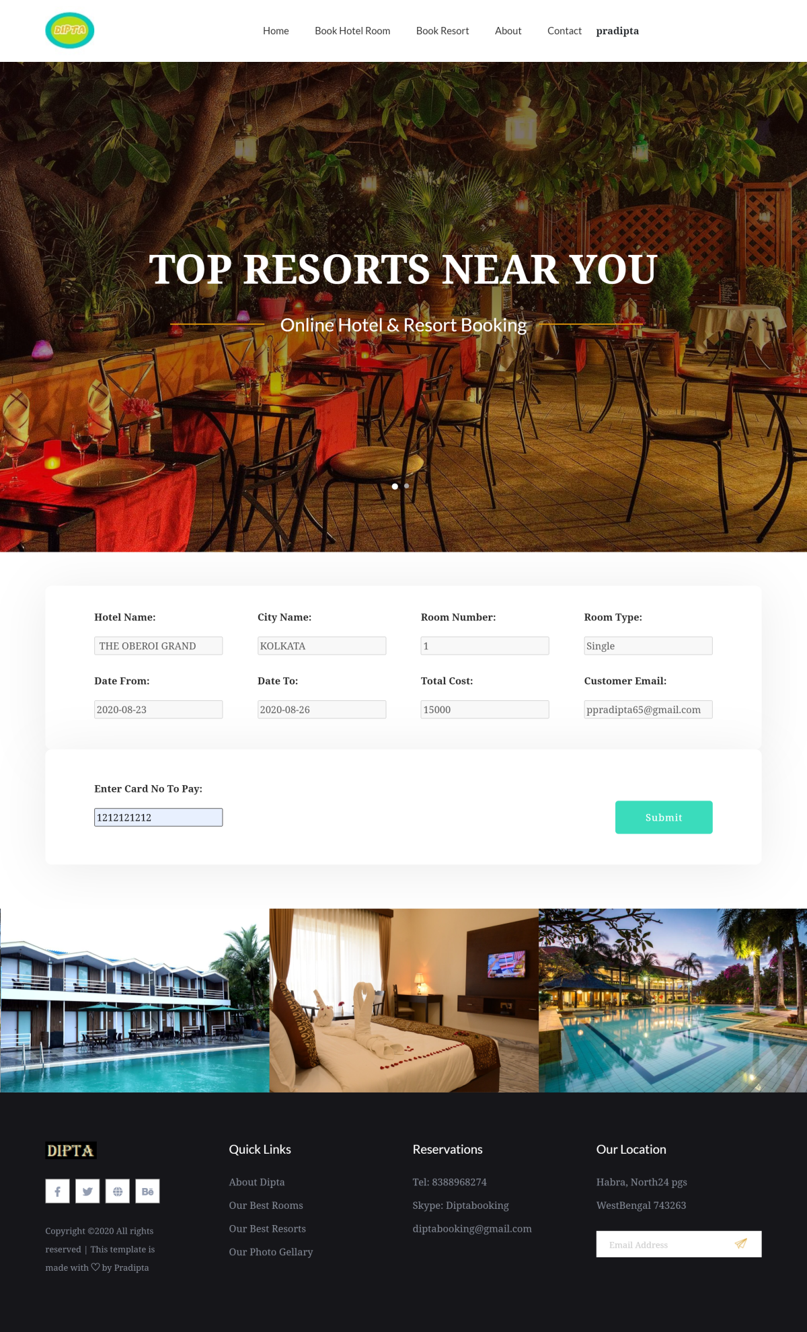

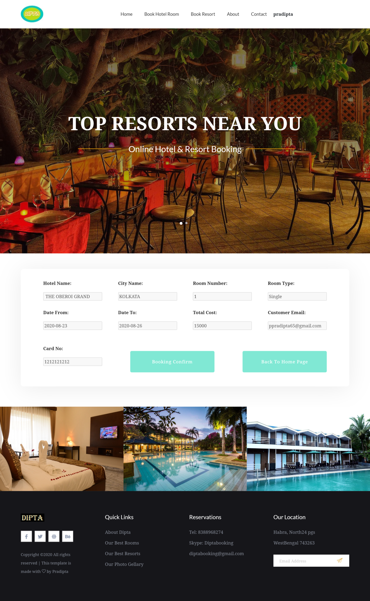

1. Booking and payment process of Resort is very simple. After clicking on **book** from **‘book_by_rname.php’** or **‘book_by_cnamer.php’** pages, itwill take users to the **‘bookr.php’** page where user can see all details of their booking resort. There user have to select the **check-in date** and **check-out date** to book resort. After selecting that the total amount and total number of days will display. Now for payment press the button **pay.** It will take user to the **‘payr.php’** page. Here user has to enter their debit or credit card number for payment. After giving the card number press submit button to payment. After submitting the booking will be done and **‘recieptr.php’** will open which will show the status the booking. From this page user can go the home page.

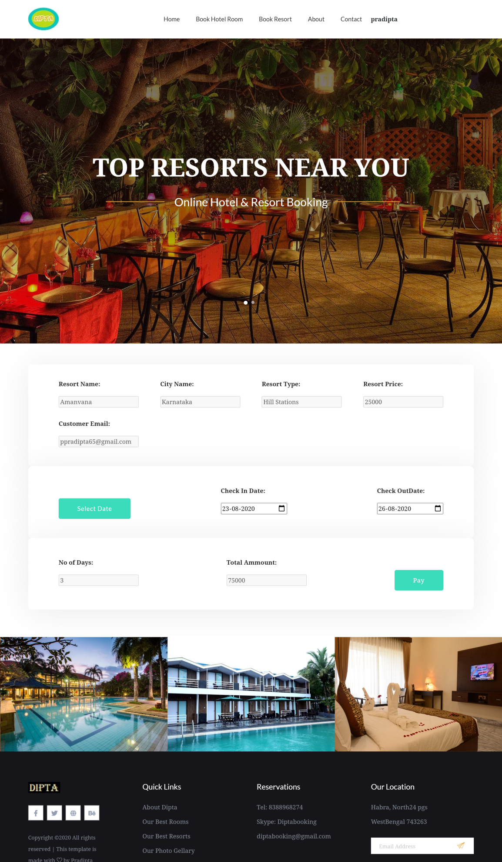

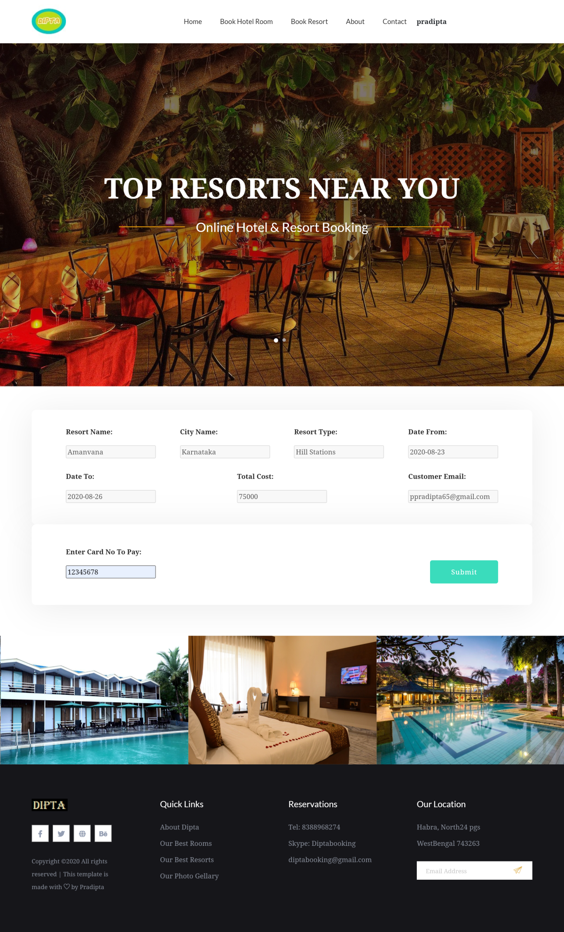

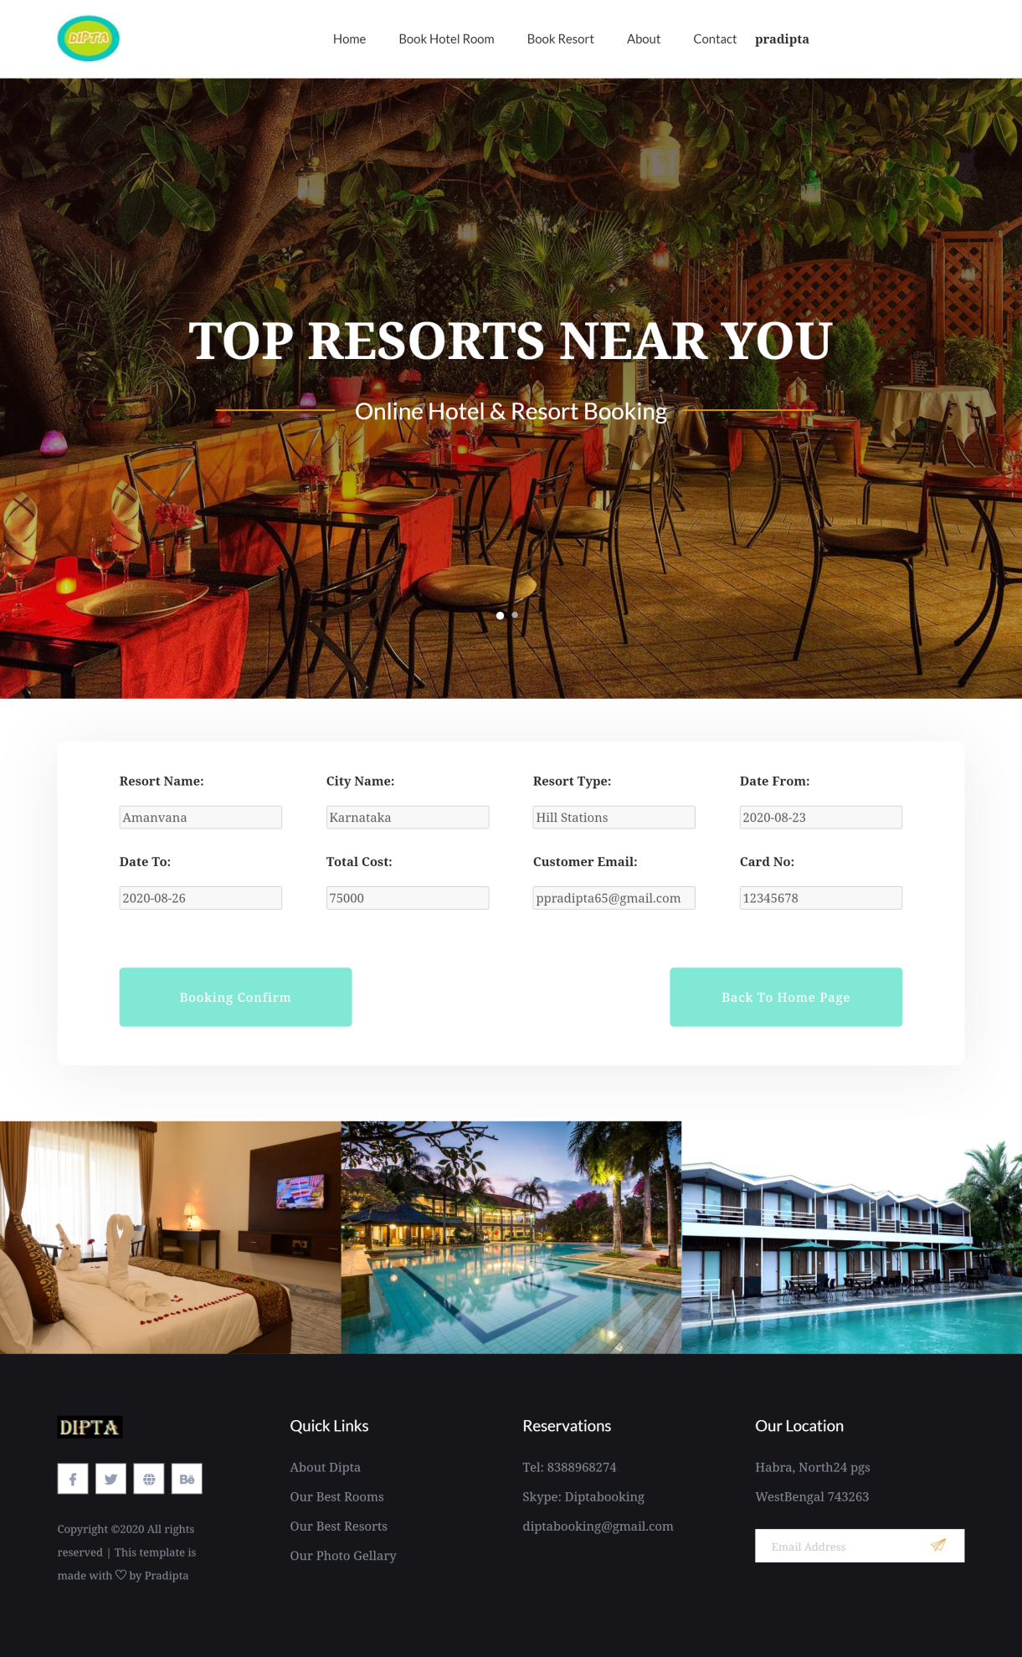

1. To see the booked hotel and resort after login user has to drag the mouse on their name on the navigation bar. There they can see the **‘Logout’ and ‘My Bookings’.** Press logout to **logout** that will take user to the **‘index.php’** page or press **My Bookings** to view all bookings that will take you to the page **‘bookings.php’.**

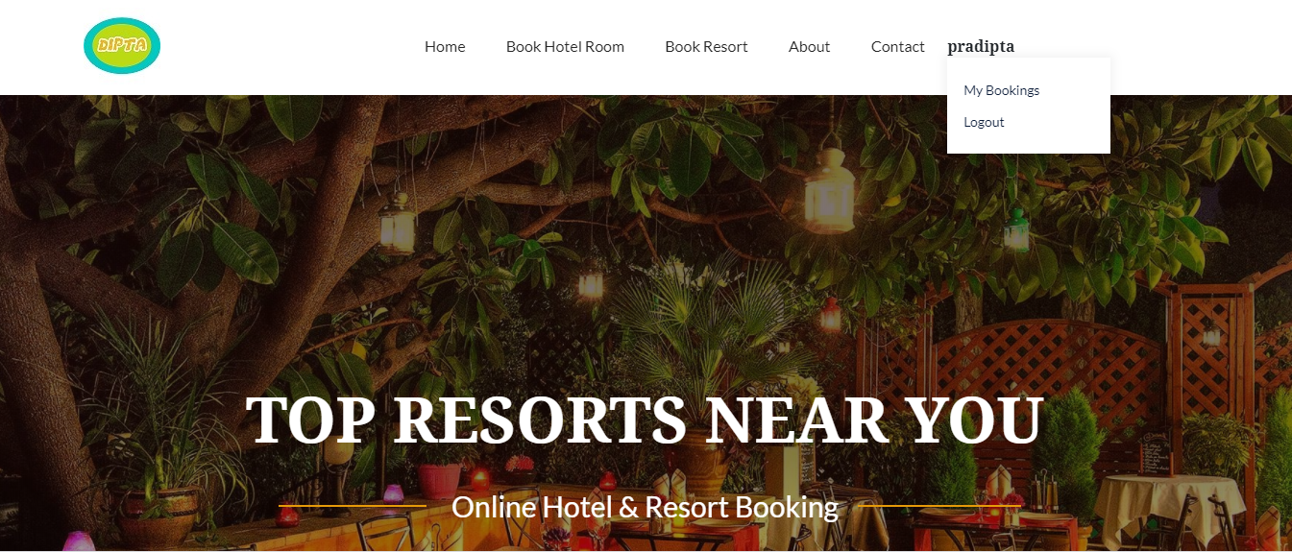

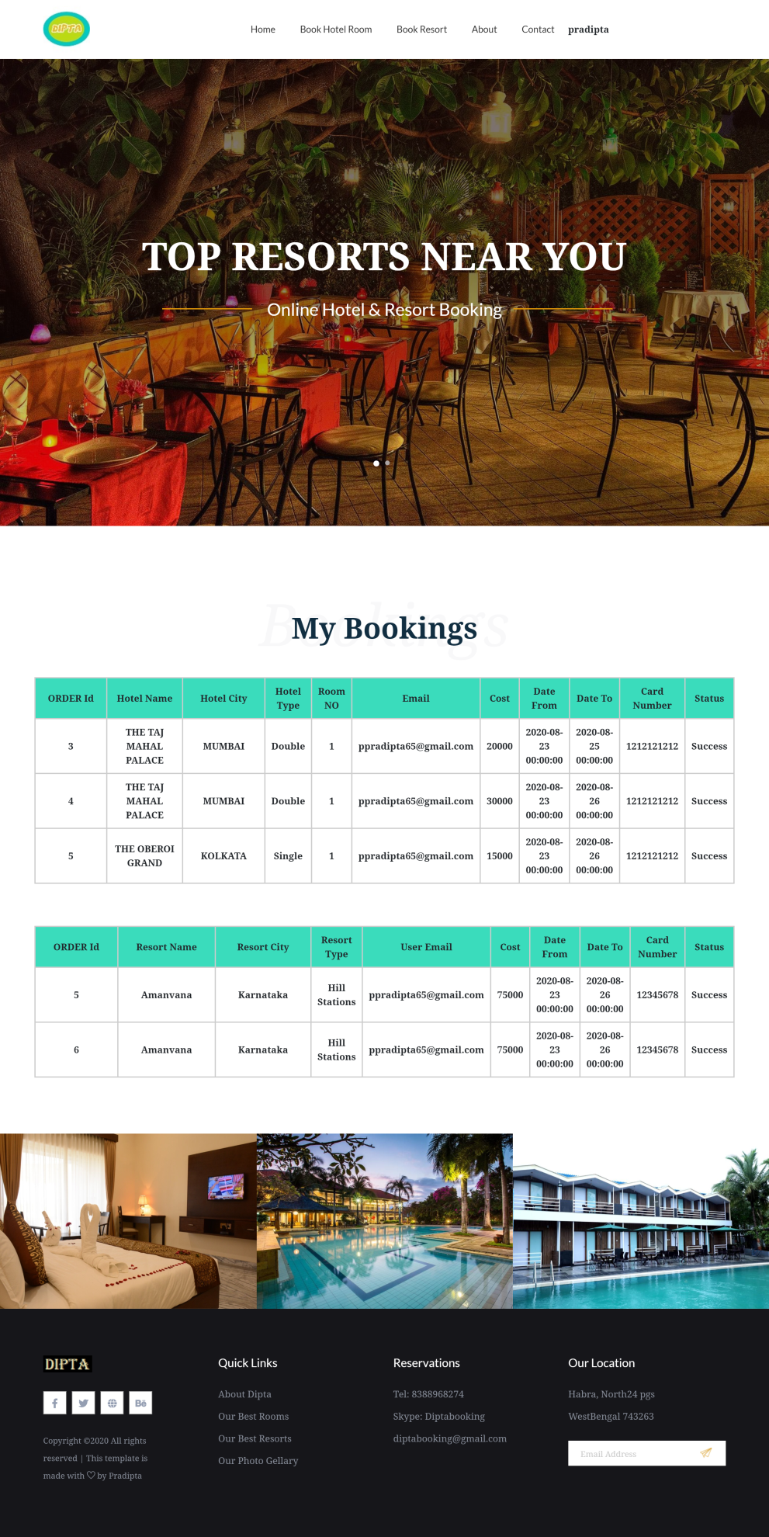

**CONCLUSION**

The main objective of the application is to help computer science students understand the basics of php, JavaScript, and HTML. By browsing through the application and looking at the code for each graphical interpretation, students should be able to easily understand the implementation. The following results have been achieved after the completing the system and relate back to the system’s objective.

1. **Should allow computer science students to browse through the code and application:** This is achieved when users, i.e., computer science students, are able to run and install the application. When they run the application, they can browse through the implementation of different objects.

2. **Should allow users to browse through different hotels in different places :** This is achieved when the user first runs the application and is directed to a home/index page that has hotels available for all places. The user can browse and click on any place to view all the hotels for that particular place.

**LIMITATION**

* Application did not disclose full information.
* Data collected in this field are not sufficient.
* The system also don’t have the online banking (**MayBank2U, CIMB Clicks, PayPal**) for customers.

**FUTURE SCOPE OF THE PROJECT**

This project ONLINE HOTELS & RESORTS BOOKING SITE has the following future scopes :-

The following section discusses the work that will be implemented with future releases of the software.

1. **Detailed places:** Future work could involve adding more places which are more detailed and have additional hotels in that place.
2. **Watch/Wish List:** Work can add a watch list or wish list so that users can add a room to a list to watch for room prices to go down or to see when there is a sale on any of those rooms.
3. **Enhanced User Interface:** Work on enhancing the user interface by adding more user-interactive features.
4. **Recommended Hotels:** Add a bar that would display the most-recommended hotels which would depend on the number of times a hotel has been booked by any users.
5. **Payment Options:** Add different payment options, such as Visa, MasterCard, PayPal, etc., where a user can also save the card information for later checkouts.

**BIBLIOGRAPHY**

* **Fundamentals of Software Engineering :**
  + Author: Rajib Mall
  + Publication: PHI
* **An Integrated Approach to Software Engineering** 
  + Authors: Pankaj Jalota
  + Publication: Narosa Publishing House
* **Database System Concepts :**
  + Authors: Silberschatz, Korth & Sudarshan
  + Publication: McGraw Hill
* **Fundamentals of Database systems**
  + Author:Elmasri Navathe.
  + Publication: PHI.
* **php Server Programming**
  + Php: The Complete Reference
  + Publication: McGraw Hill India

~~END~~